Description:

I have built application for mange check-in and Inflight service and Admin services in Airline using React and Redux.

**Project Name**: **airline-checkin**

**Environment:**

**Due to more fize, I have removed nodmodules folder, please install all required packages.**

**Ex.**

**npm install --save react-router-dom**

**npm install --save redux react-redux**

**npm install --save-dev redux-immutable-state-invariant**

**npm install react-google-login**

**npm install @material-ui/core**

**npm install @material-ui/icons**

**npm install — save node-sass**

**npm install react-datetime-picker**

**npm install --save react-seat-picker**

npm install react-tooltip

**npm install react-select --save**

**npm install bootstrap –save**

node –version: v12.16.0

npm –version: 6.13.7

IDE: visual studio

Refer package.json for more details

{

  "name": "airline-checkin",

  "version": "0.1.0",

  "private": true,

  "dependencies": {

    "@material-ui/core": "^4.9.5",

    "@material-ui/icons": "^4.9.1",

    "@testing-library/jest-dom": "^4.2.4",

    "@testing-library/react": "^9.4.1",

    "@testing-library/user-event": "^7.2.1",

    "bootstrap": "^4.4.1",

    "react": "^16.13.0",

    "react-datetime-picker": "^2.9.0",

    "react-dom": "^16.13.0",

    "react-google-login": "^5.1.1",

    "react-redux": "^7.2.0",

    "react-router-dom": "^5.1.2",

    "react-scripts": "3.4.0",

    "react-seat-picker": "^1.5.2",

    "react-select": "^3.0.8",

    "react-tooltip": "^4.1.1",

    "redux": "^4.0.5"

  },

  "scripts": {

    "start": "react-scripts start",

    "build": "react-scripts build",

    "test": "react-scripts test",

    "eject": "react-scripts eject"

  },

  "eslintConfig": {

    "extends": "react-app"

  },

  "browserslist": {

    "production": [

      ">0.2%",

      "not dead",

      "not op_mini all"

    ],

    "development": [

      "last 1 chrome version",

      "last 1 firefox version",

      "last 1 safari version"

    ]

  },

  "devDependencies": {

    "redux-immutable-state-invariant": "^2.1.0"

  }

}

**Instructions to Start application:**

1. Unzip the given file and open project folder in visual studio or any react support editors.
2. Before you need to install node and npm
3. Open project folder in either editor terminal or cmd promt.
4. Then execute command “**npm start**”, for local. Then application will open in <http://localhost:3000/>
5. If execute command “**npm run build**”, for production. Then application will open on <http://localhost:5000/>

For this I have configured both URLs in google oAuth client.

1. I have implemented Google authenticator, application ask login. I have provided login details in home page itself, but real case it not like.

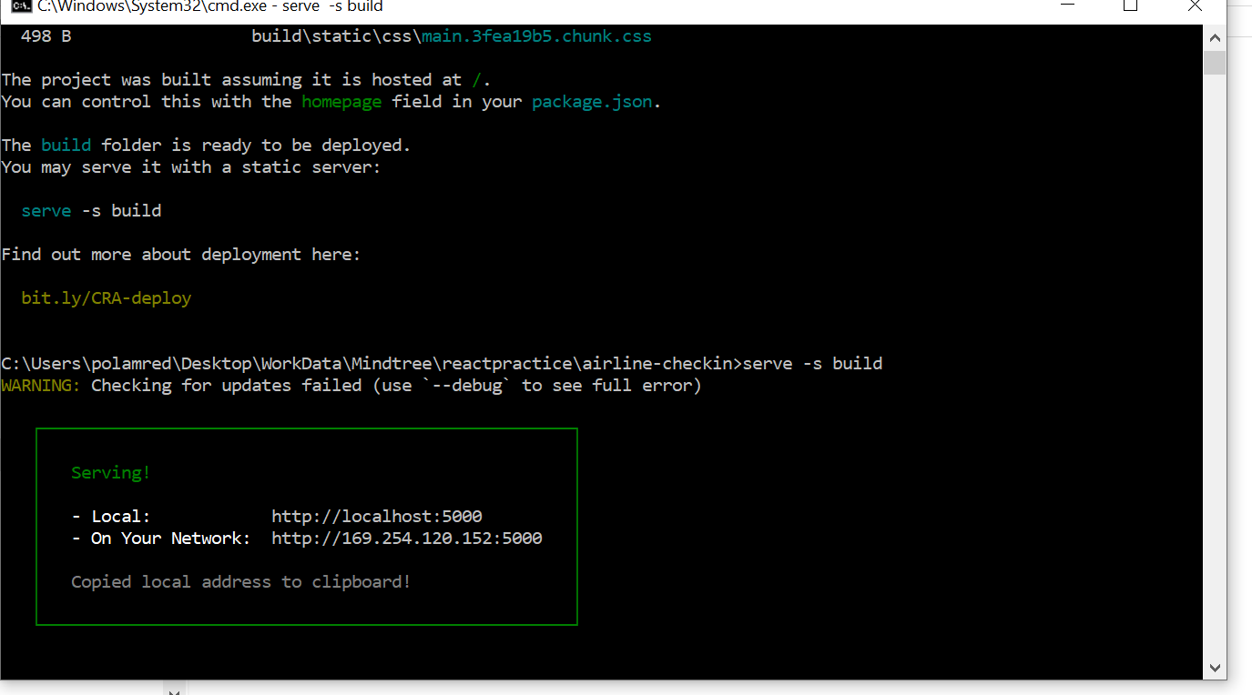

Production:

npm install -g serve

serve -s build

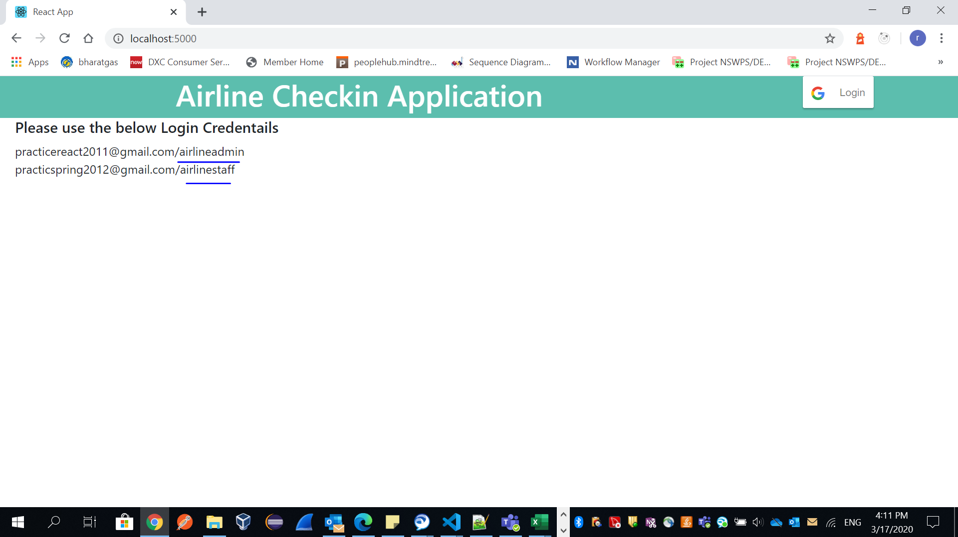

I have created one user for each role, for my testing. We can edit this in LoginApp.js file.

Please use the below Login Credentails

**practicereact2011@gmail.com/airlineadmin**

**practicspring2012@gmail.com/airlinestaff**

if (response.profileObj.email === 'practicereact2011@gmail.com')

         {

             role = 'admin';

         } else if (response.profileObj.email === 'practicspring2012@gmail.com') {

             role = 'staff';

         }

I have installed **Lighthouse** plugin in browser. Please refer bellow report

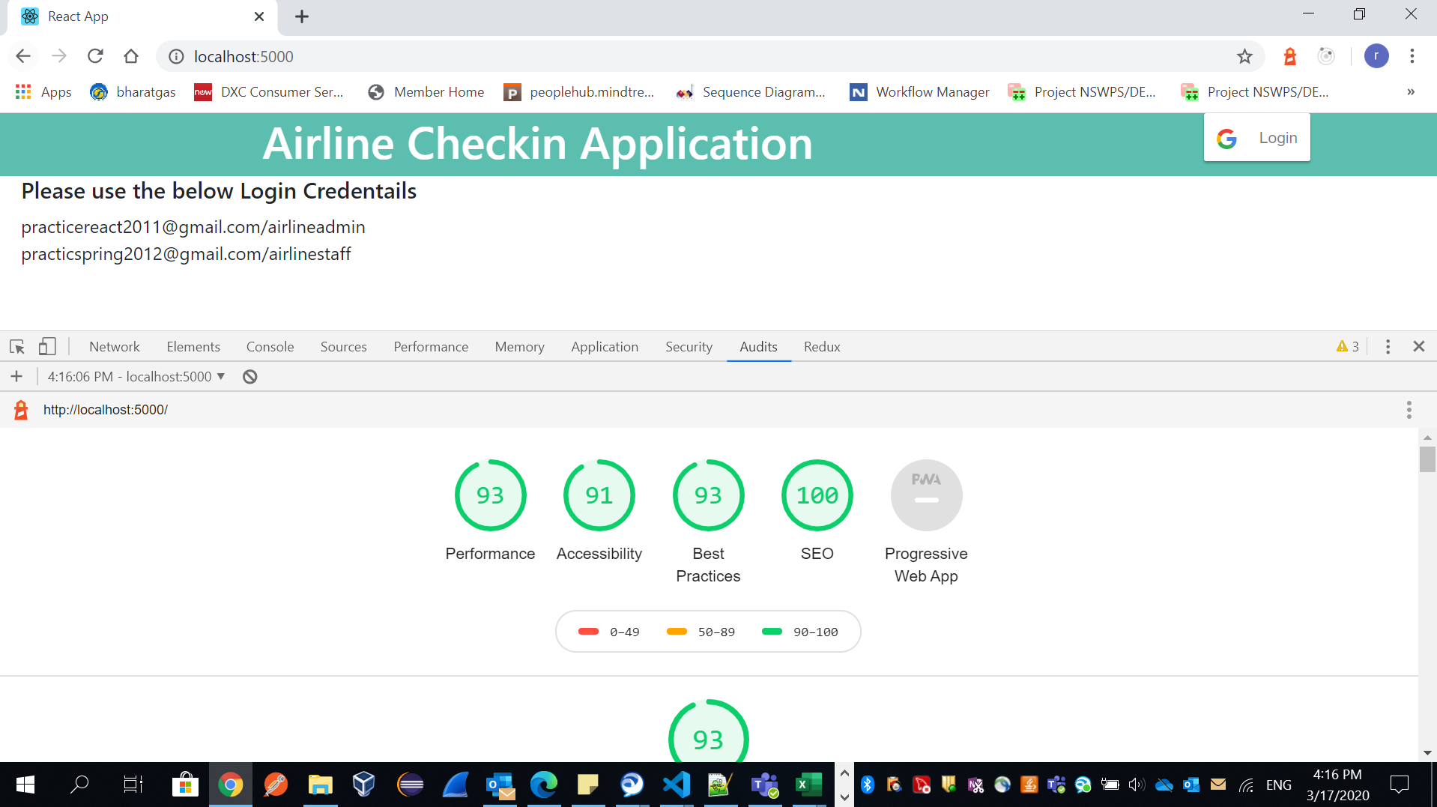

**Note: Don’t refresh browser, because we will lose Redux store Data.**

**Admin Role:**

Once login with admin credentials it will lands in add passenger gefault page.

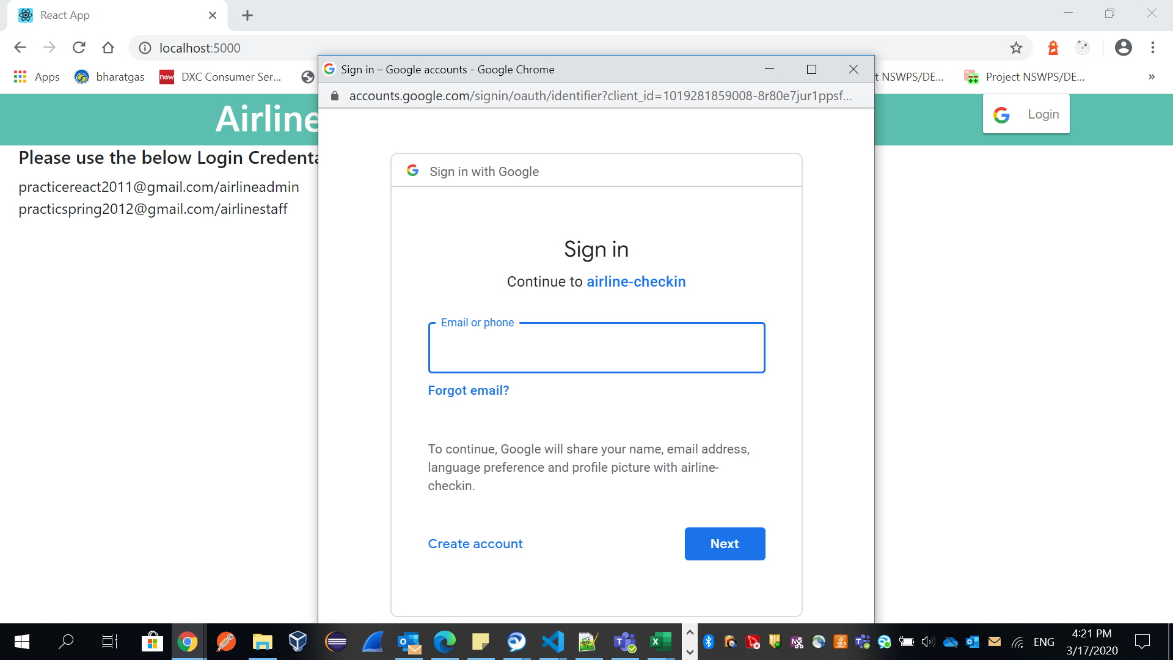

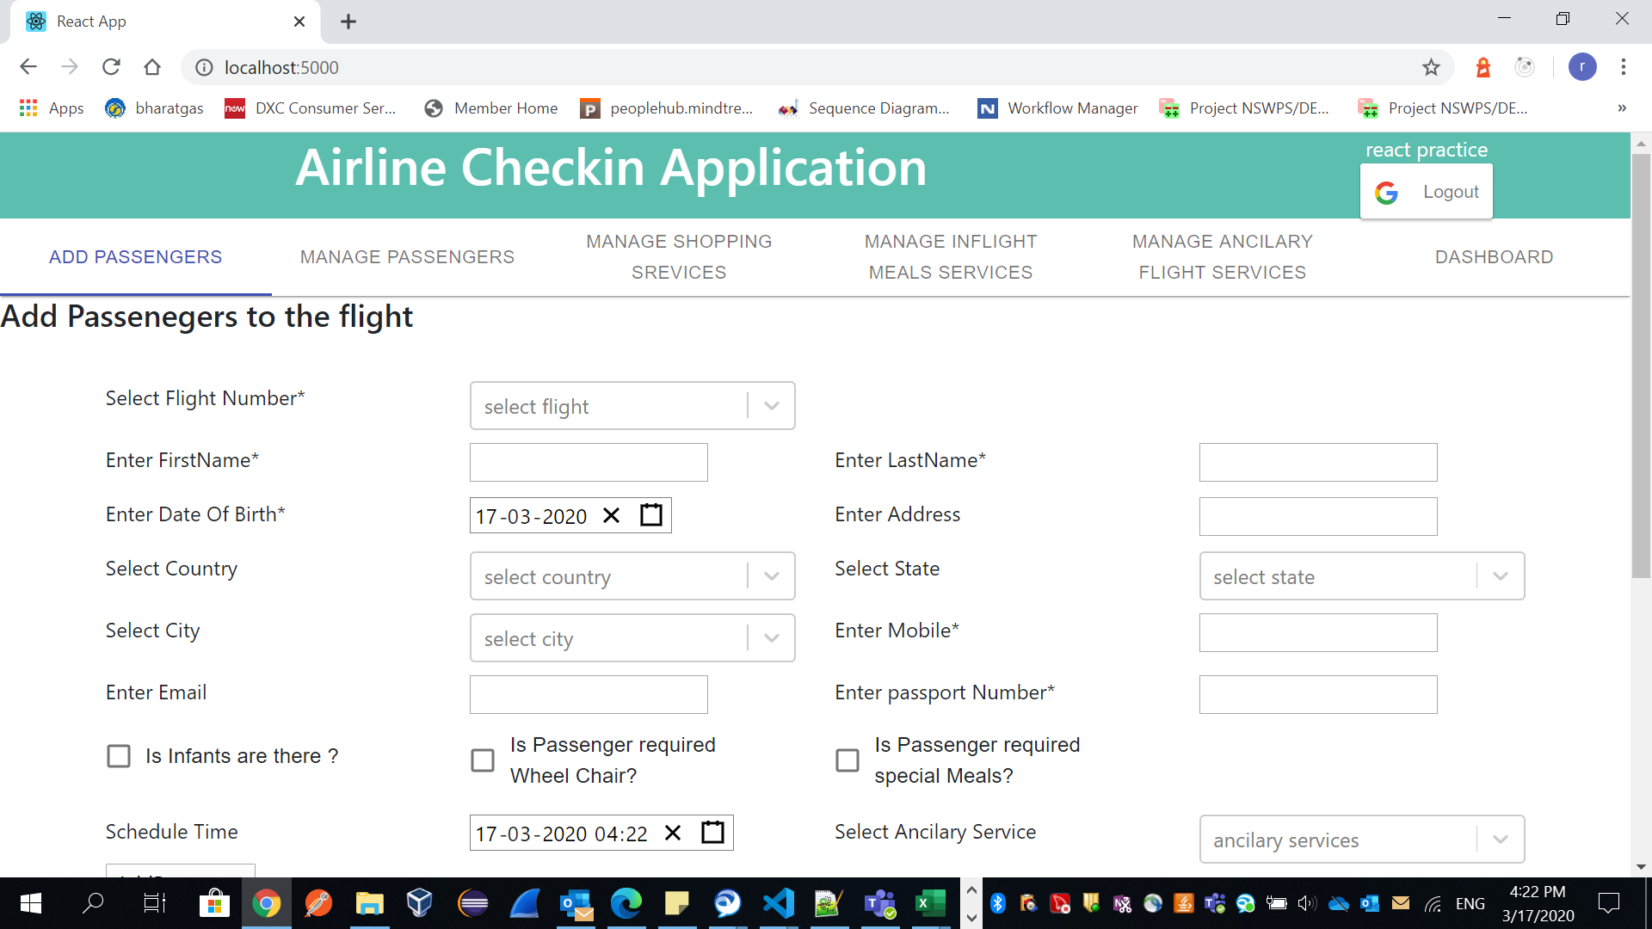

First we need Add ancilary service to flight

I have assumed Flight, and ancialry, melpreference, shopping items are coming from anther system. For in this I have bring those information via constant store file. We can edit/add based on requirement

**mataData.js**

export const  flights = [

    { label: "UL461", value: 'UL461', boarding:'Chennai', destination:'Tokyo', airlinesName: 'Srilanka Airlines' },

    { label: "UL125", value: 'UL125', boarding:'Hyderabad', destination:'Delhi', airlinesName: 'Srilanka Airlines'  },

    { label: "UL462", value: 'UL462', boarding:'Bangalore', destination:'Tokyo', airlinesName: 'Srilanka Airlines'  },

    { label: "UL126", value: 'UL126', boarding:'Chennai', destination:'London', airlinesName: 'Srilanka Airlines'  },

    { label: "UL463", value: 'UL463', boarding:'Chennai', destination:'Newyork', airlinesName: 'Srilanka Airlines'  },

    { label: "UL127", value: 'UL127', boarding:'Chennai', destination:'Germany', airlinesName: 'Srilanka Airlines'  },

    { label: "UL430", value: 'UL430', boarding:'Chennai', destination:'Tokyo', airlinesName: 'Srilanka Airlines' },

    { label: "UL908", value: 'UL908', boarding:'Hyderabad', destination:'Delhi', airlinesName: 'Srilanka Airlines'  },

    { label: "UL405", value: 'UL405', boarding:'Bangalore', destination:'Tokyo', airlinesName: 'Srilanka Airlines'  },

    { label: "UL104", value: 'UL104', boarding:'Chennai', destination:'London', airlinesName: 'Srilanka Airlines'  },

    { label: "UL103", value: 'UL103', boarding:'Chennai', destination:'Newyork', airlinesName: 'Srilanka Airlines'  },

    { label: "UL102", value: 'UL102', boarding:'Chennai', destination:'Germany', airlinesName: 'Srilanka Airlines'  },

];

export const  countries = [

    { label: "India", value: 'India' },

    { label: "USA", value: 'USA' },

    { label: "UK", value: 'UK' },

    { label: "Japan", value: 'Japan' },

    { label: "Srilanka", value: 'Srilanka' },

    { label: "Chaina", value: 'Chaina' },

];

export const  states = [

    { label: "Tamilnadu", value: 'Tamilnadu' },

    { label: "Karnataka", value: 'Karnataka' },

    { label: "Kawasaki", value: 'Kawasaki' },

    { label: "New Jersy", value: 'New Jersy' },

    { label: "Telangana", value: 'Telangana' },

    { label: "Telangana", value: 'Telangana' },

];

export const  cities = [

    { label: "Hyderabad", value: 'Hyderabad' },

    { label: "Bangalore", value: 'Bangalore' },

    { label: "Colombo", value: 'Colombo' },

    { label: "Bejing", value: 'Bejing' },

    { label: "Tokyo", value: 'Tokyo' },

    { label: "Osaka", value: 'Osaka' },

    { label: "New York", value: 'New York' },

    { label: "London", value: 'London' },

];

export const  ancilary = [

    { label: "excess-baggage", value: 'excess-baggage' },

    { label: "Frequent-flyer-programs ", value: 'Frequent-flyer-programs ' },

    { label: "Lounge-access", value: 'Lounge-access' },

    { label: "Sky-bazaar", value: 'Sky-bazaar' },

    { label: "Miles", value: 'Miles' },

    { label: "In-flight-entertainment", value: 'In-flight-entertainment' },

    { label: "Inflight-meals", value: 'Inflight-meals' }

];

export const  mealsPreferences = [

    { label: "indian-veg-breakfast", value: 'indian-veg-breakfast', desc: "tomoto rawa upma, sambar, cut fruits, vada, tamato Chutney" },

    { label: "indian-nonveg-breakfast", value: 'indian-nonveg-breakfast', desc: "parotta/chapati, cheken rost, cut fruits, juice" },

    { label: "indian-veg-lunch", value: 'indian-veg-lunch', desc:"fried rice, samber, salad, juice, raice, veg fry, manchuria, sweet"},

    { label: "indian-non-veg-lunch", value: 'indian-non-veg-lunch', desc:"checkn fry, checken biriyani, rice, fich cury, sweet"},

    { label: "chinese-Special", value: 'chinese-Special', desc:"chiken fry, fork dry, noodels, salad, drinks, choclete" },

    { label: "italy-Special", value: 'italy-Special', desc:"chiken fry, fork dry, bun, salad, drinks, choclete" },

];

export const  shoppingRequests = [

    { label: "Compact-Body-Massager", value: 'Compact-Body-Massager' },

    { label: "Foot-Massager", value: 'Foot-Massager' },

    { label: "Pain-Relief-Massager-Pen", value: 'Pain-Relief-Massager-Pen' },

    { label: "Charger-Cabels", value: 'Charger-Cabels' },

    { label: "Mobiles", value: 'Mobiles' },

    { label: "books", value: 'books' },

    { label: "laggage-bag-lockers", value: 'laggage-bag-lockers' }

];

**Adding Ancilary services to selected flight:**

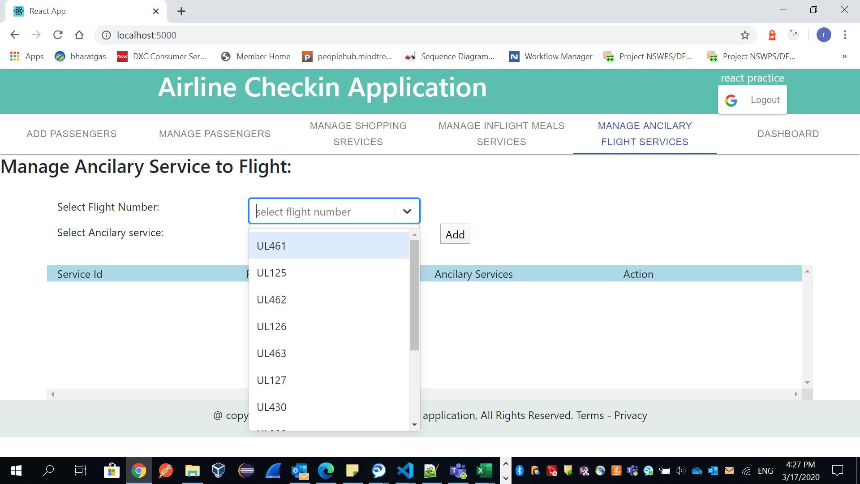

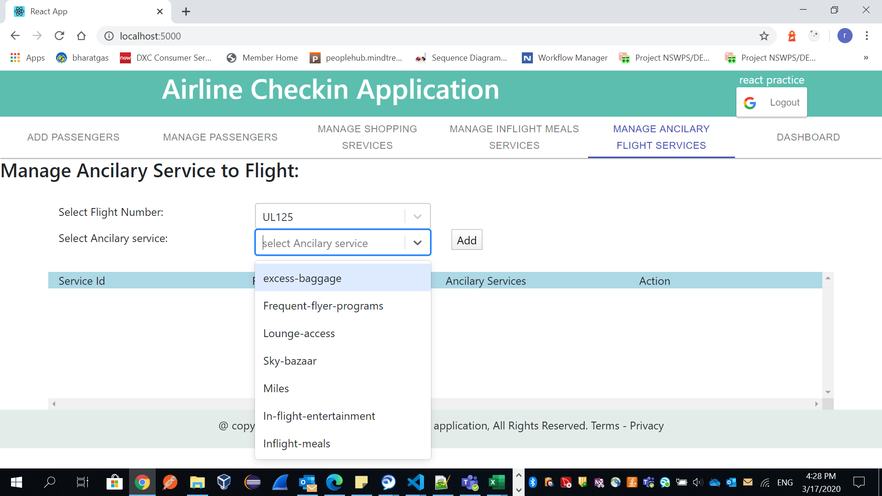

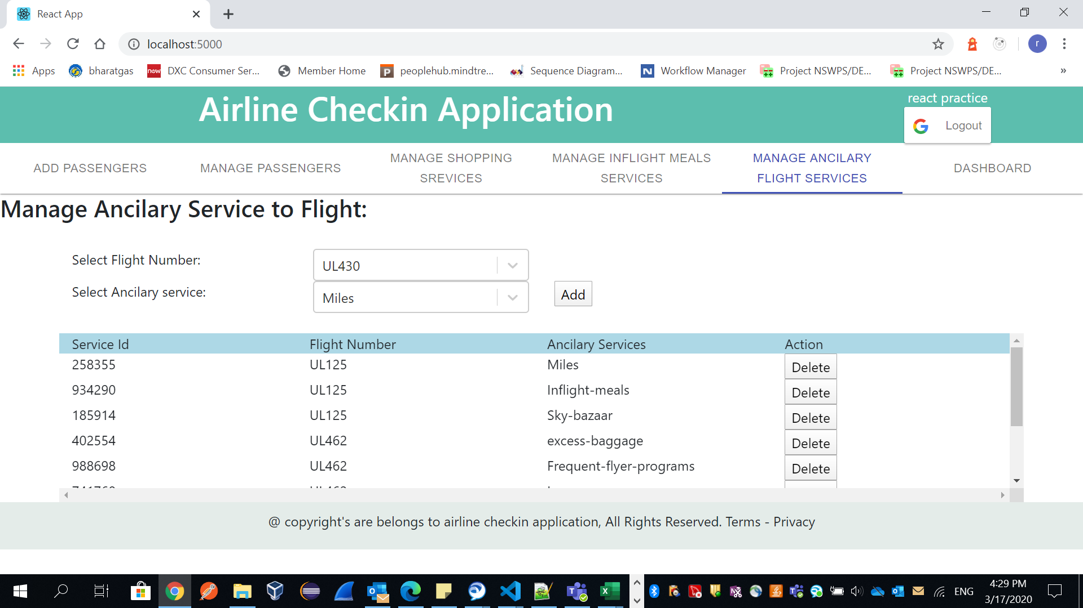

Like this we can add applicable ancilary service to coorsponding flight. And we can delete.

Ex:

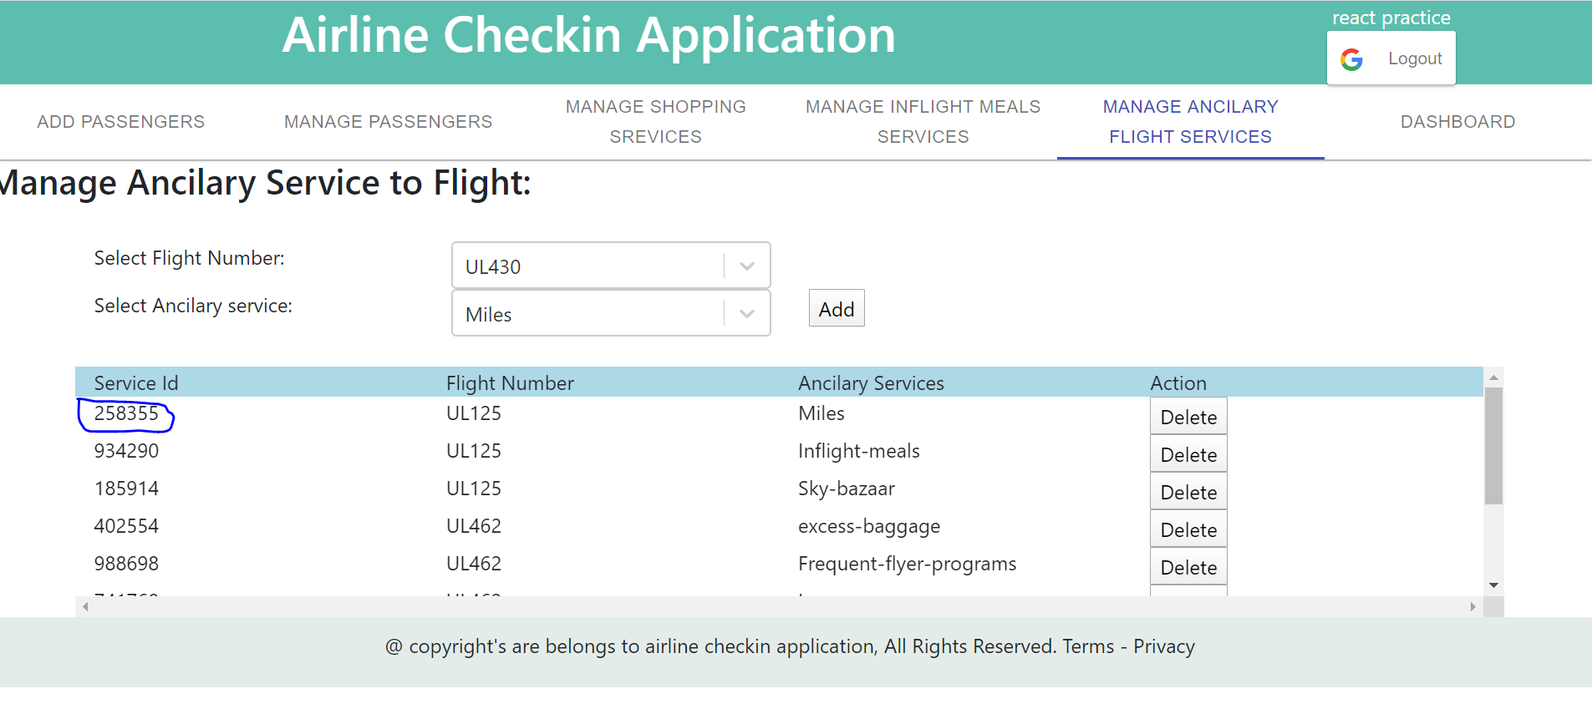

I have delete selected record.

This id’s are generating randomly. Thease are unique id’s in system.

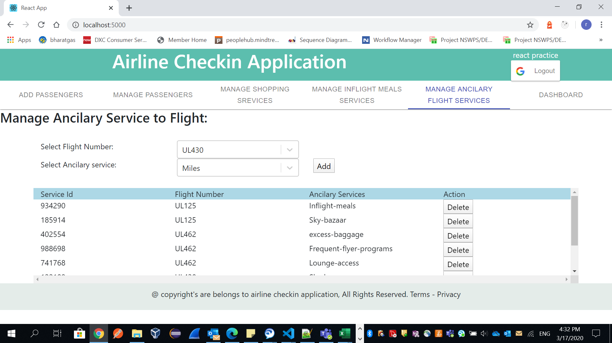

**Add MealPreference to flight:**

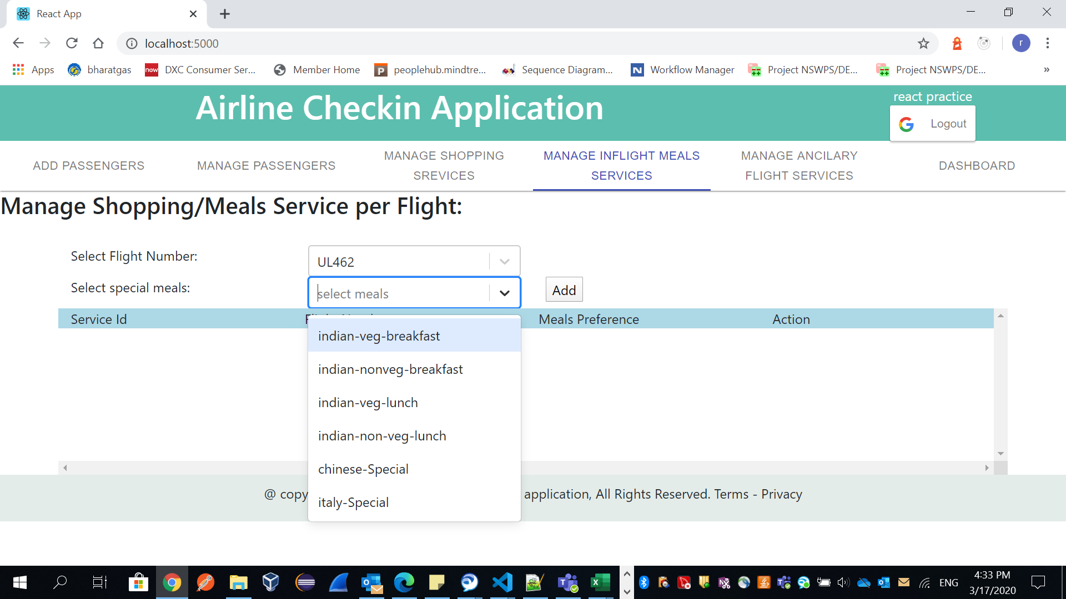

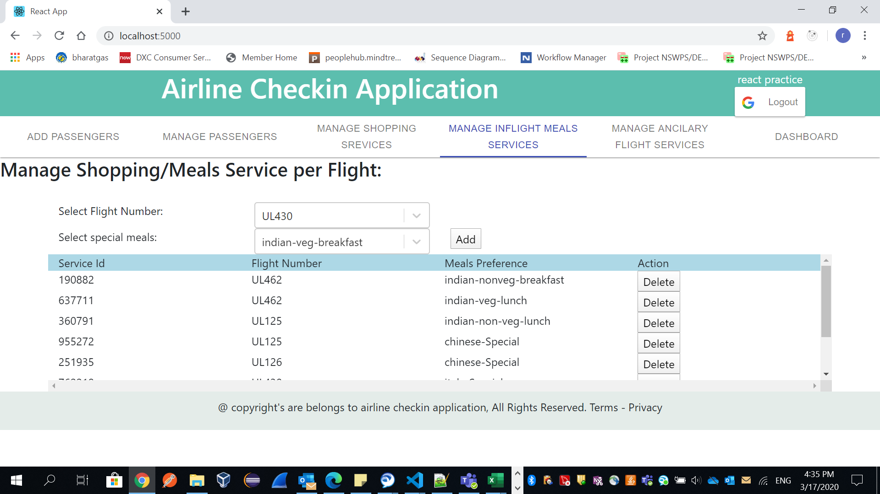

Like wise we can add/delete applicable mealprefernec to flight.

**Add shopping Items to Flight:**

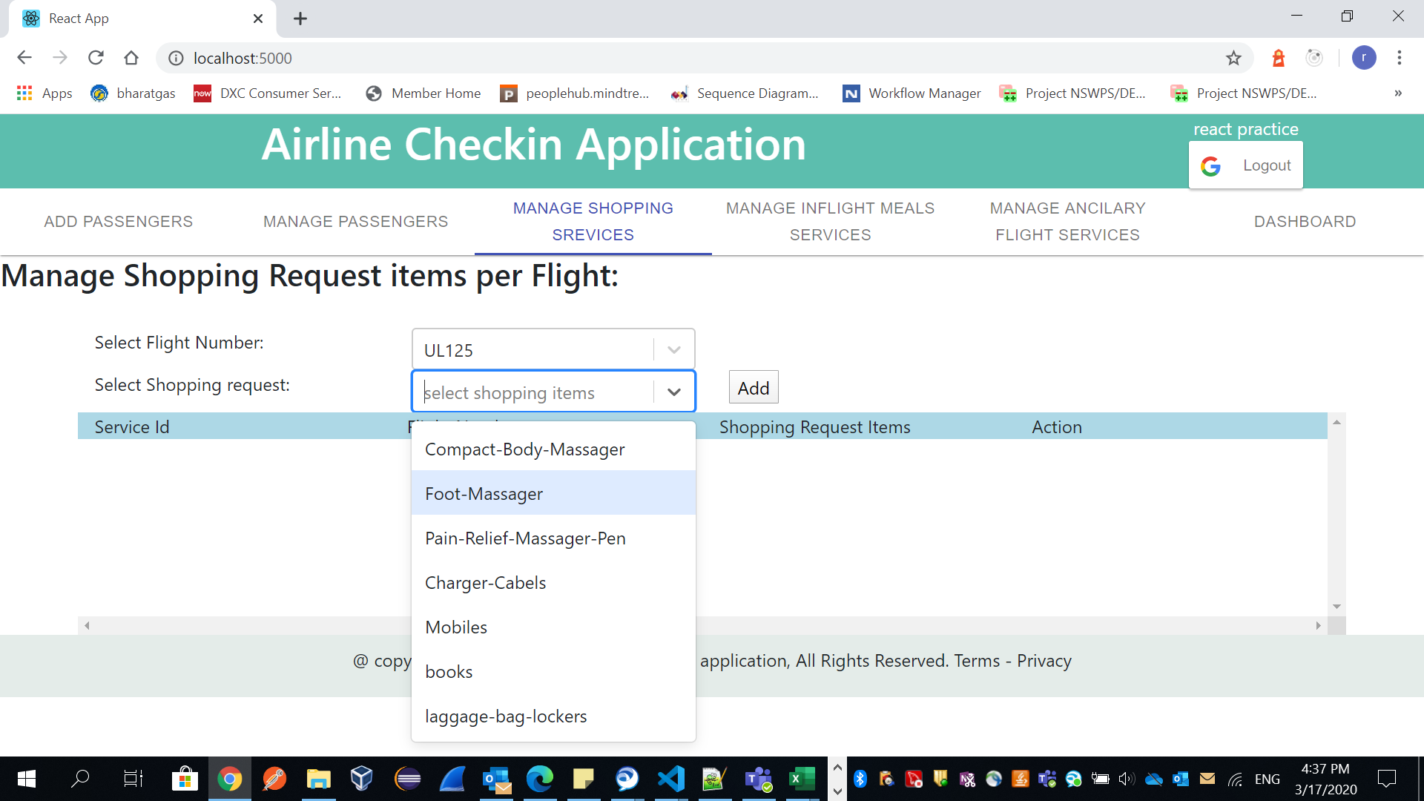

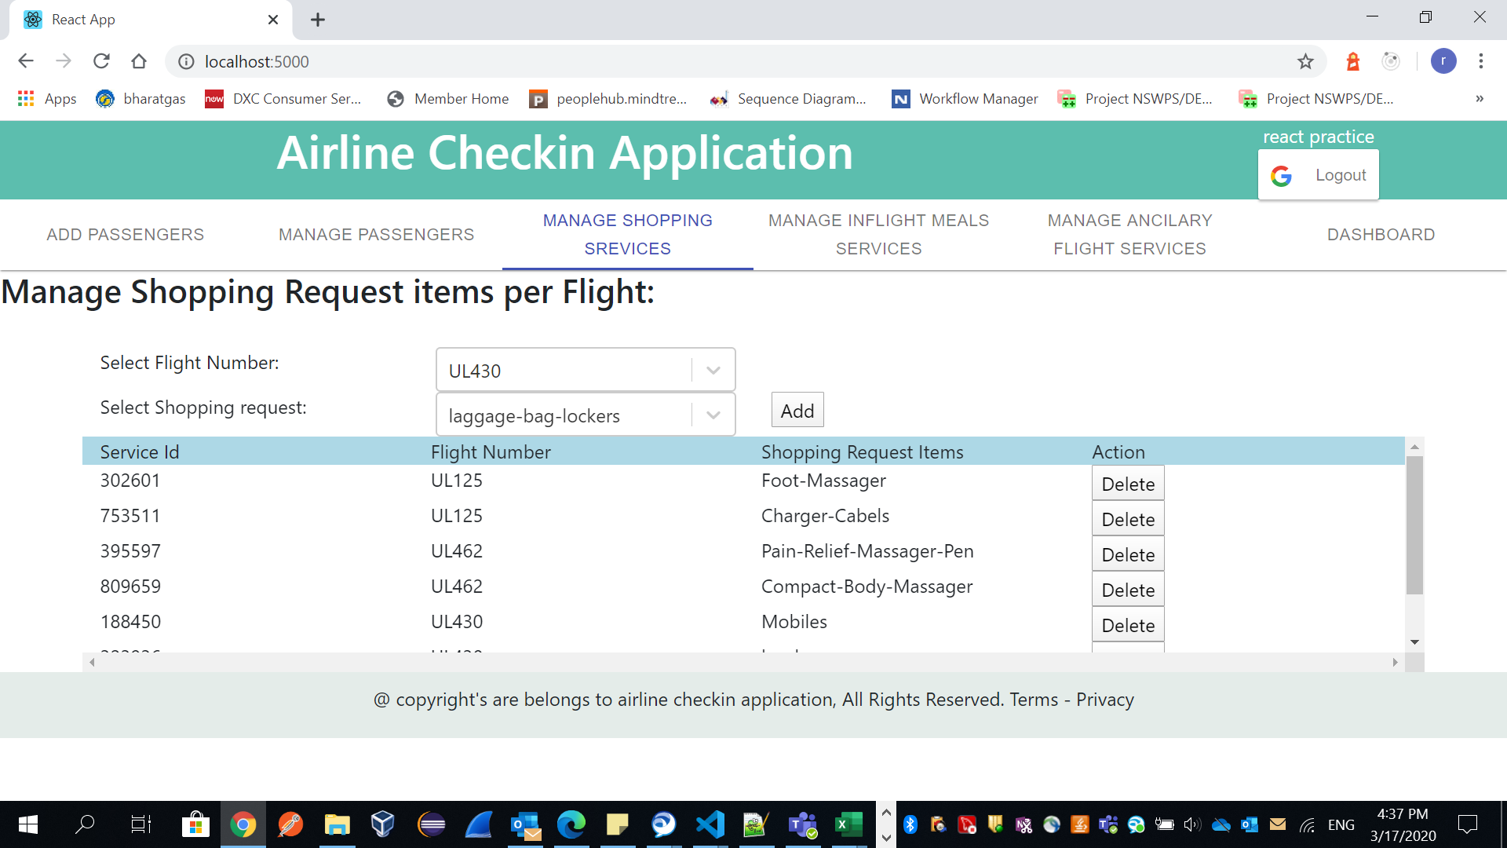

As of now we added ancilary, melasprefernces and shooping items to flights.

**Add Passenegrs to Flight:**

In real case once passenger login and book ticket, passenger details will entered in airline system.

Once we click on Add Passenger tab, we can see add passenger form to fill details.

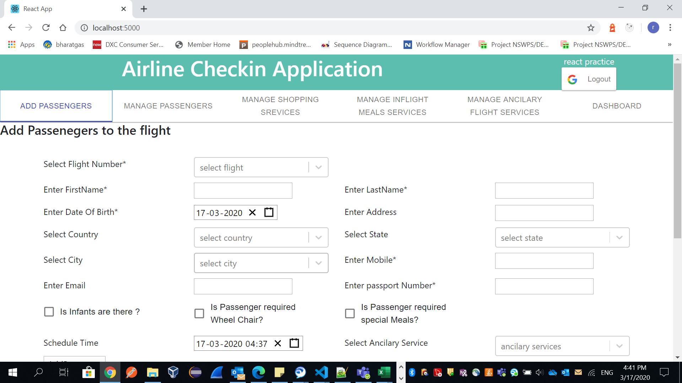

We need select the flight and add passengers to selected flight.

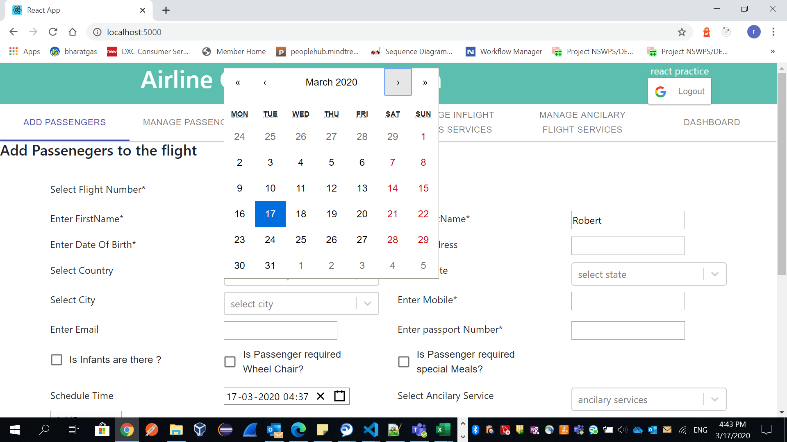

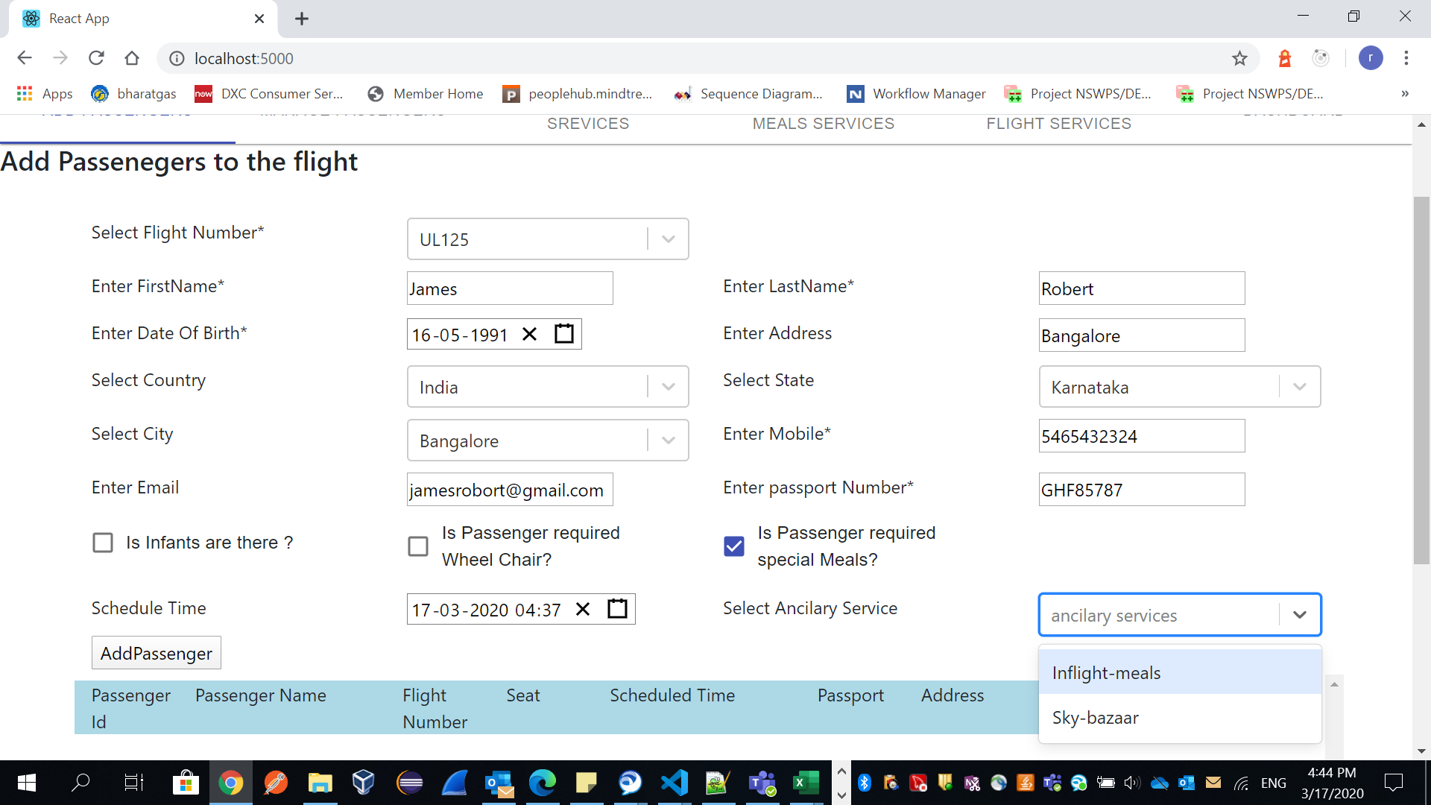

Passenger can select ancilaries what he need.

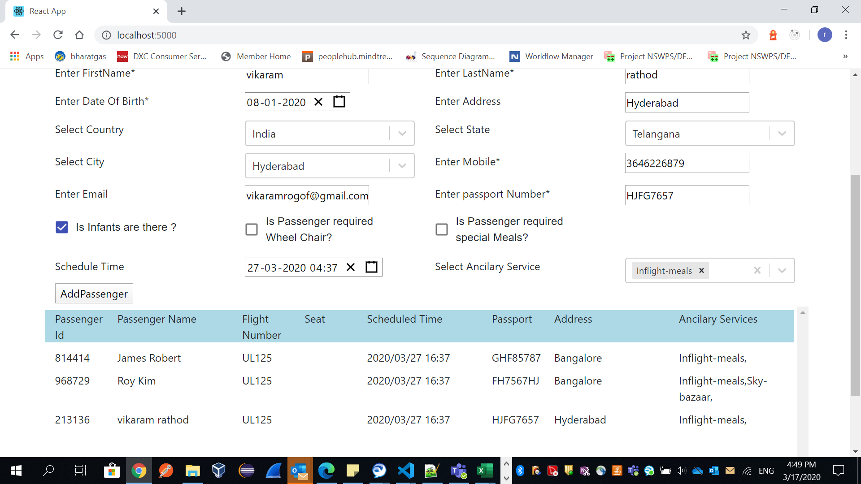

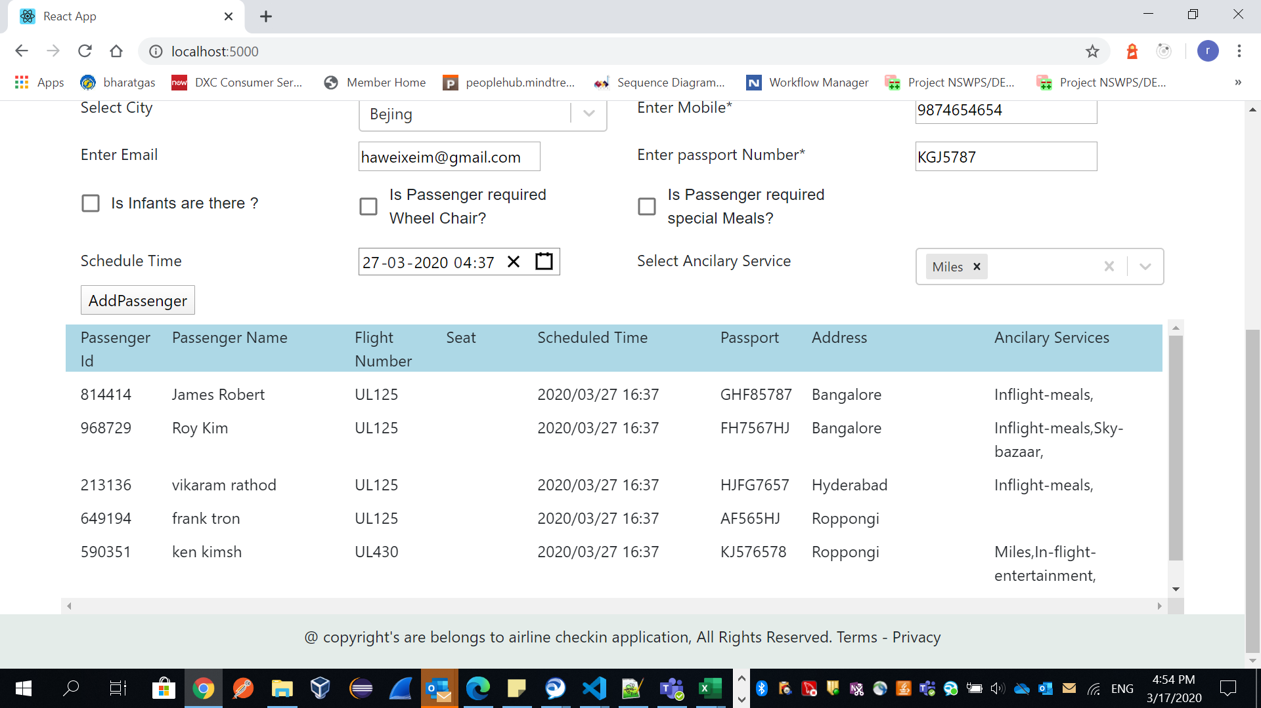

Like wise we can add all passengers to flights. And here passenger id is unique random generated number.

**Manage Passengers:**

Here we need to select flight to view passenegers details or delete.

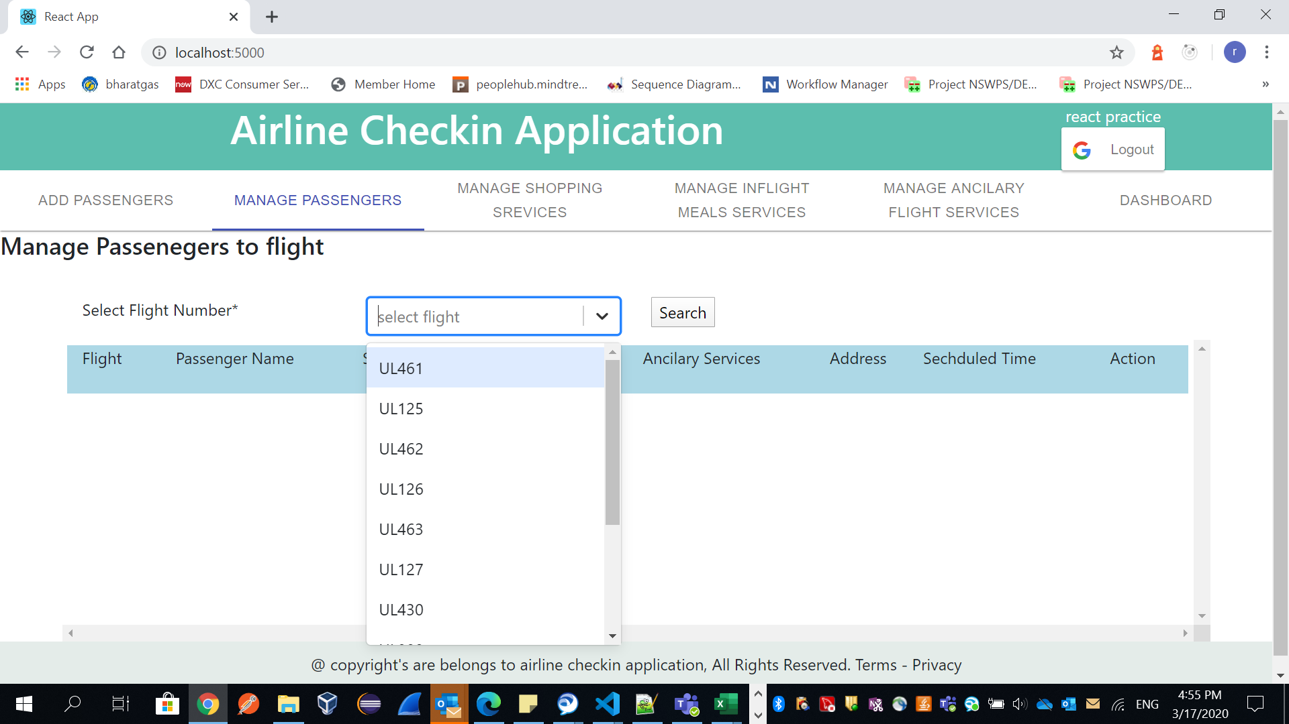

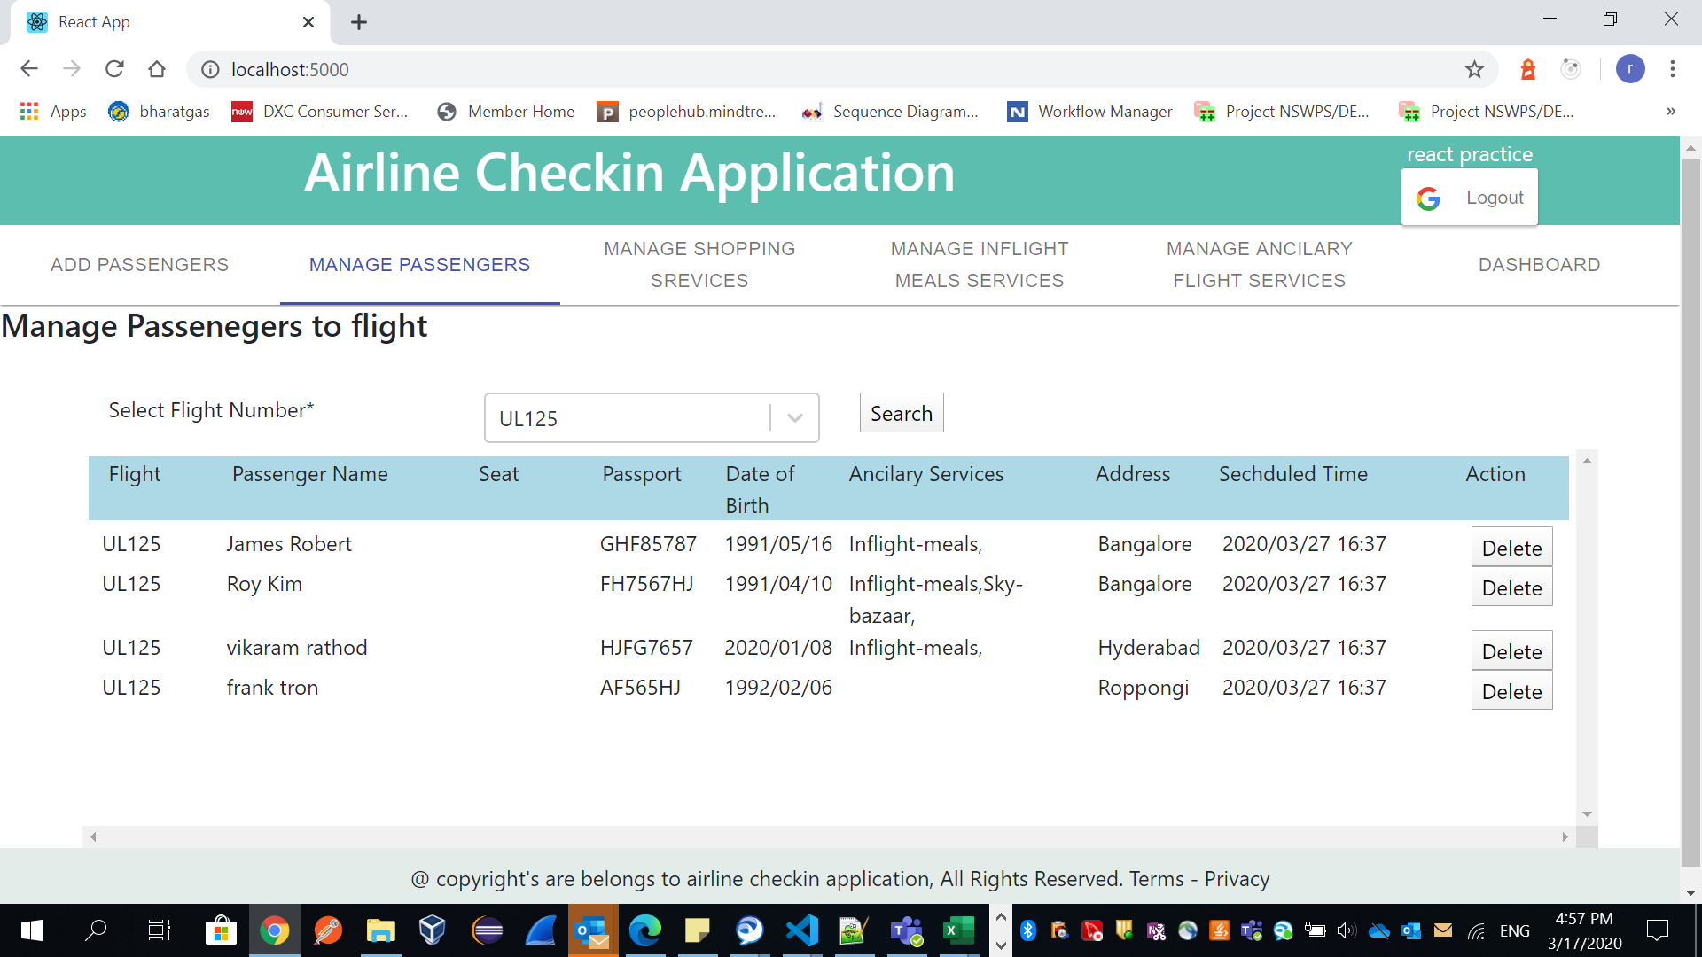

Now am deleting one passenger in flight UL125.

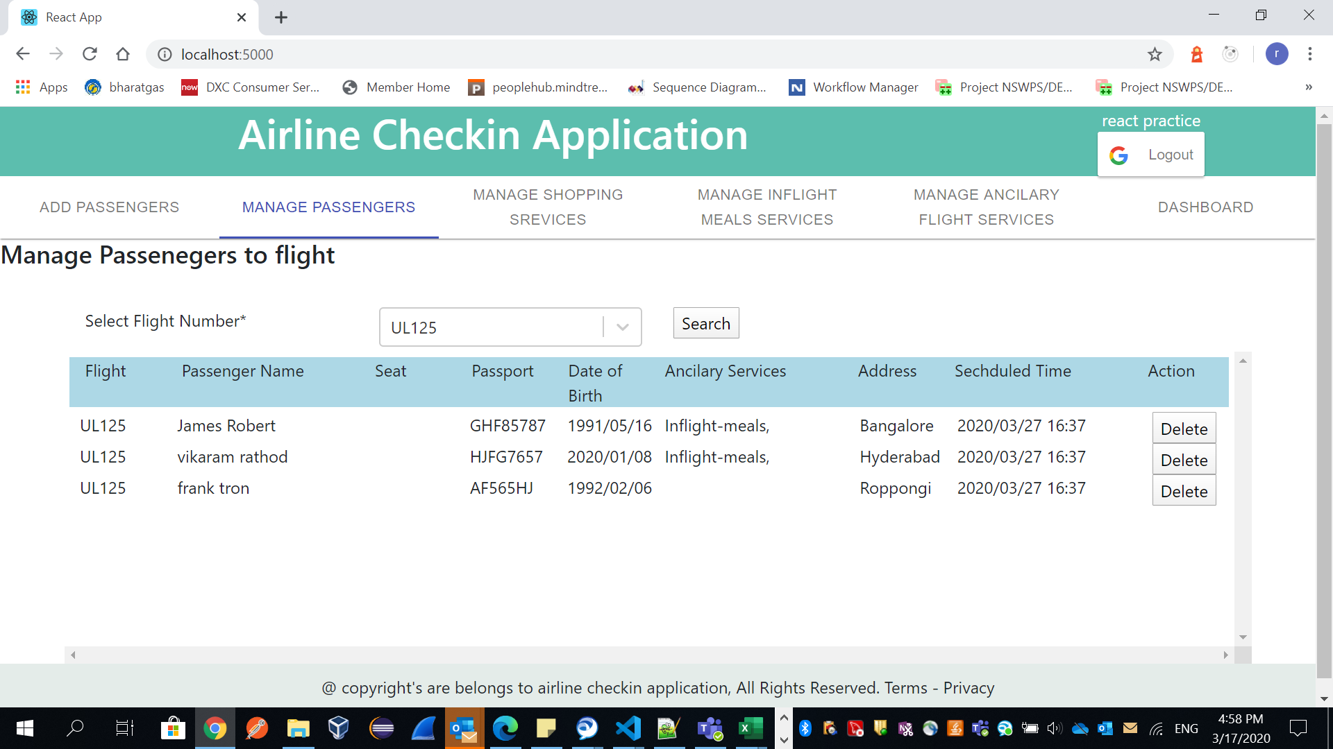

Select flight and click on deleet to see udated data, because as per my design I didn,t set state to this object.

**Note: Don’t refresh browser, because we will lose Redux store Data.**

**Dashbord:**

Dashbord we can we filter passengers like no passport, daat of birth and address

Note. All should be empty

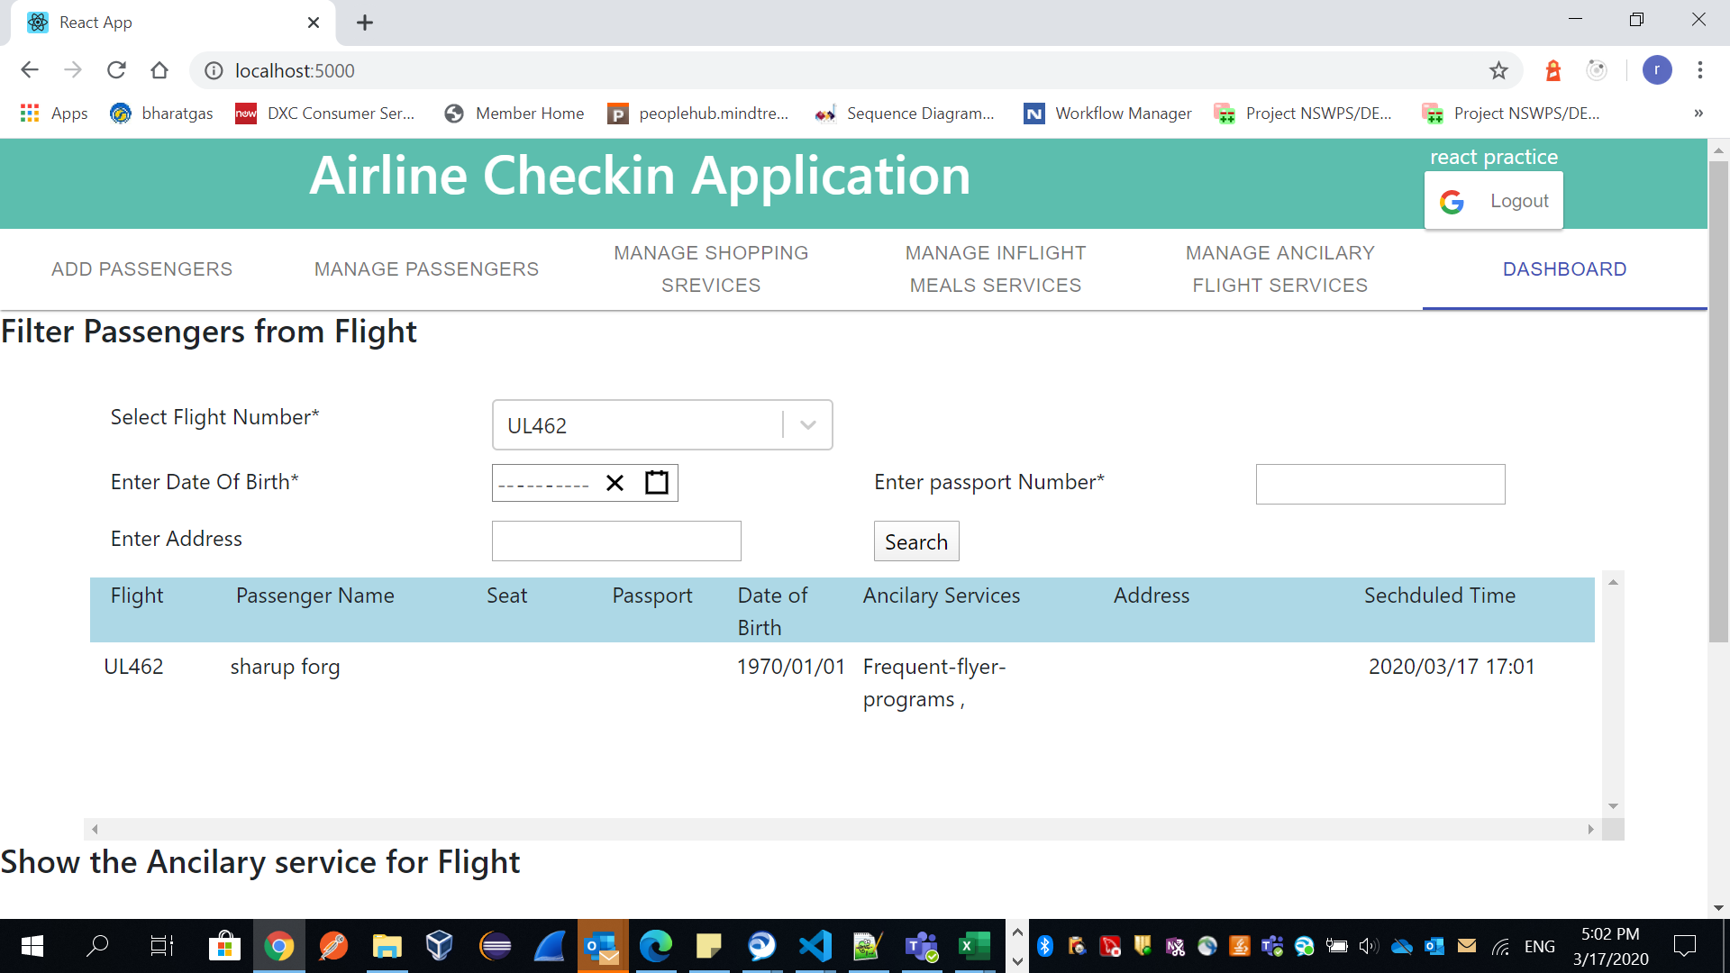

**And also user can we ancillary filter based on flight.**

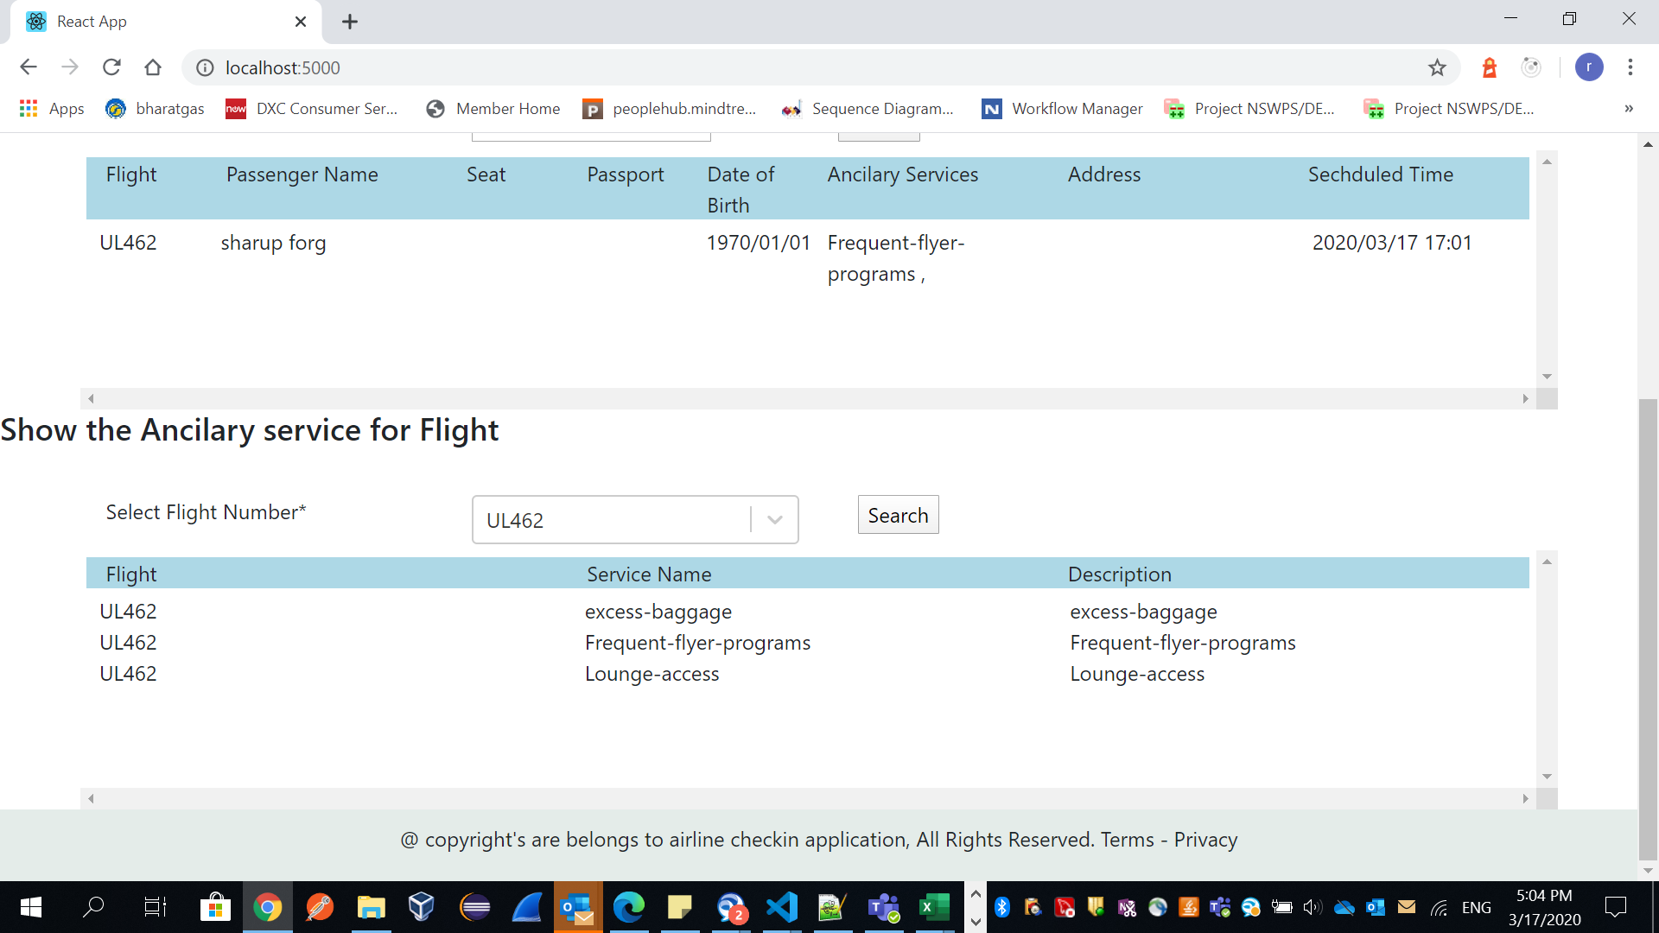

**Note: Don’t refresh browser, because we will lose Redux store Data.**

**Staff:**

Once staff user login, he lands into check-in dashboard screen.

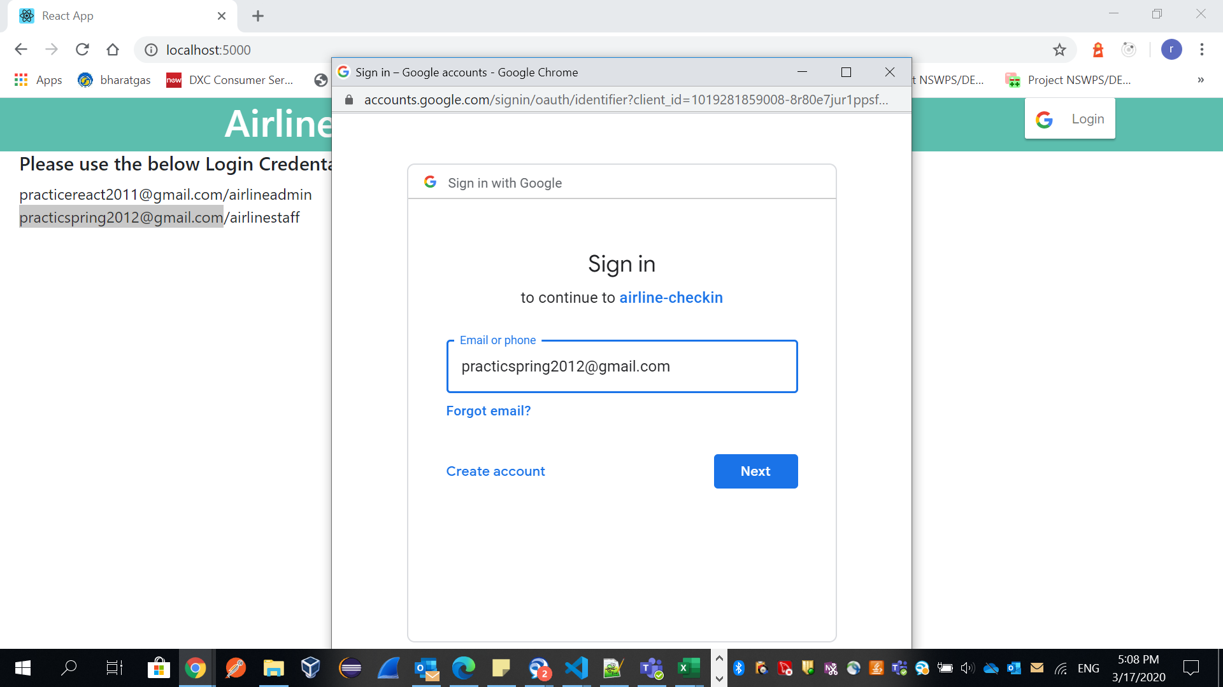

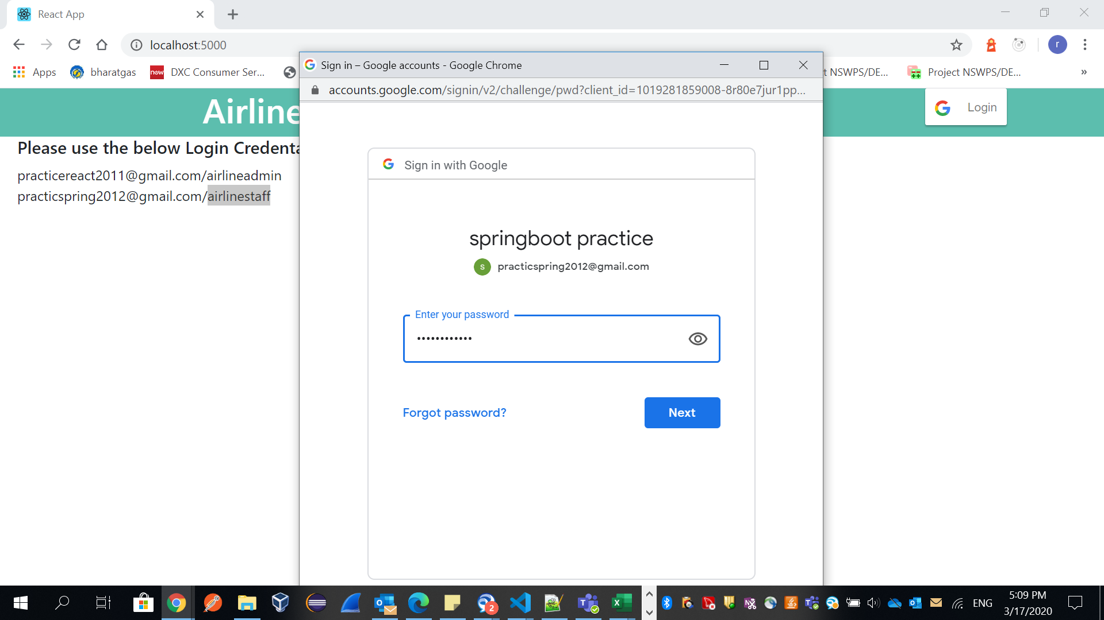

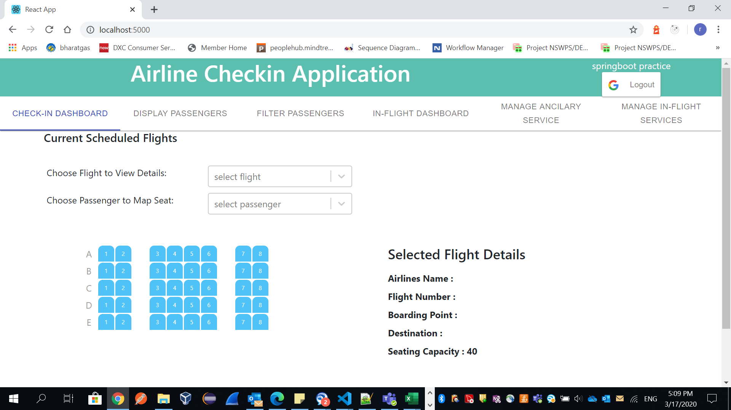

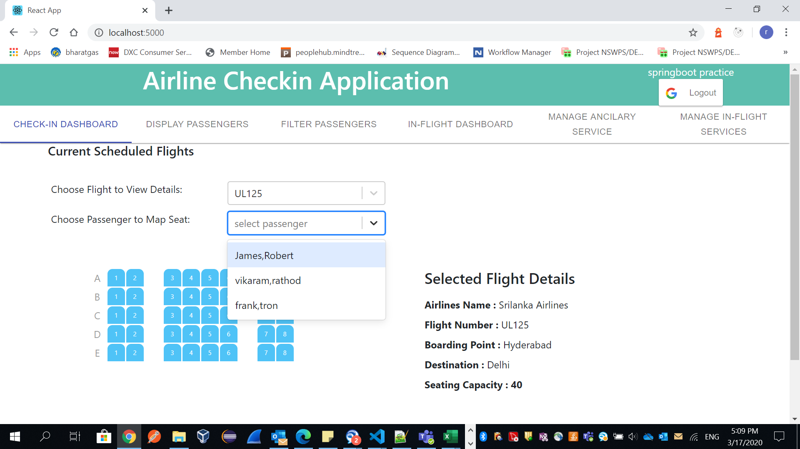

Once passenger came, airline staff can book seat while check-in process.

Passenger can check-in seat or un check-in

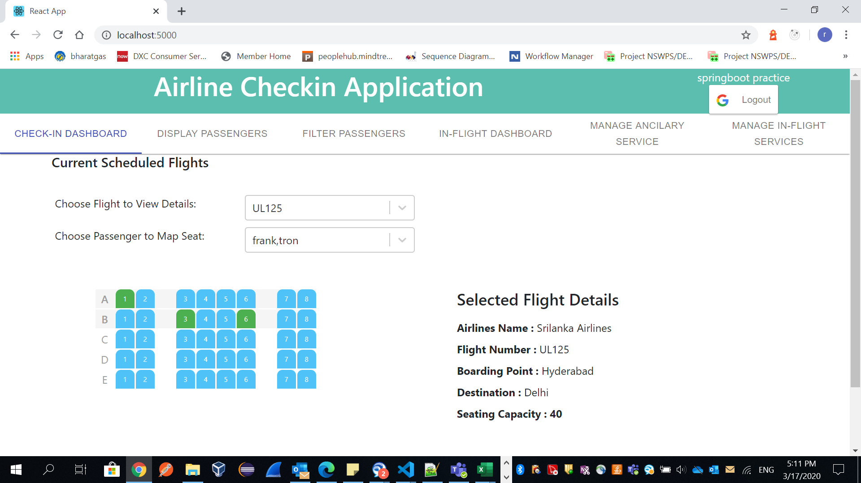

We can see passengers detail in display screen.

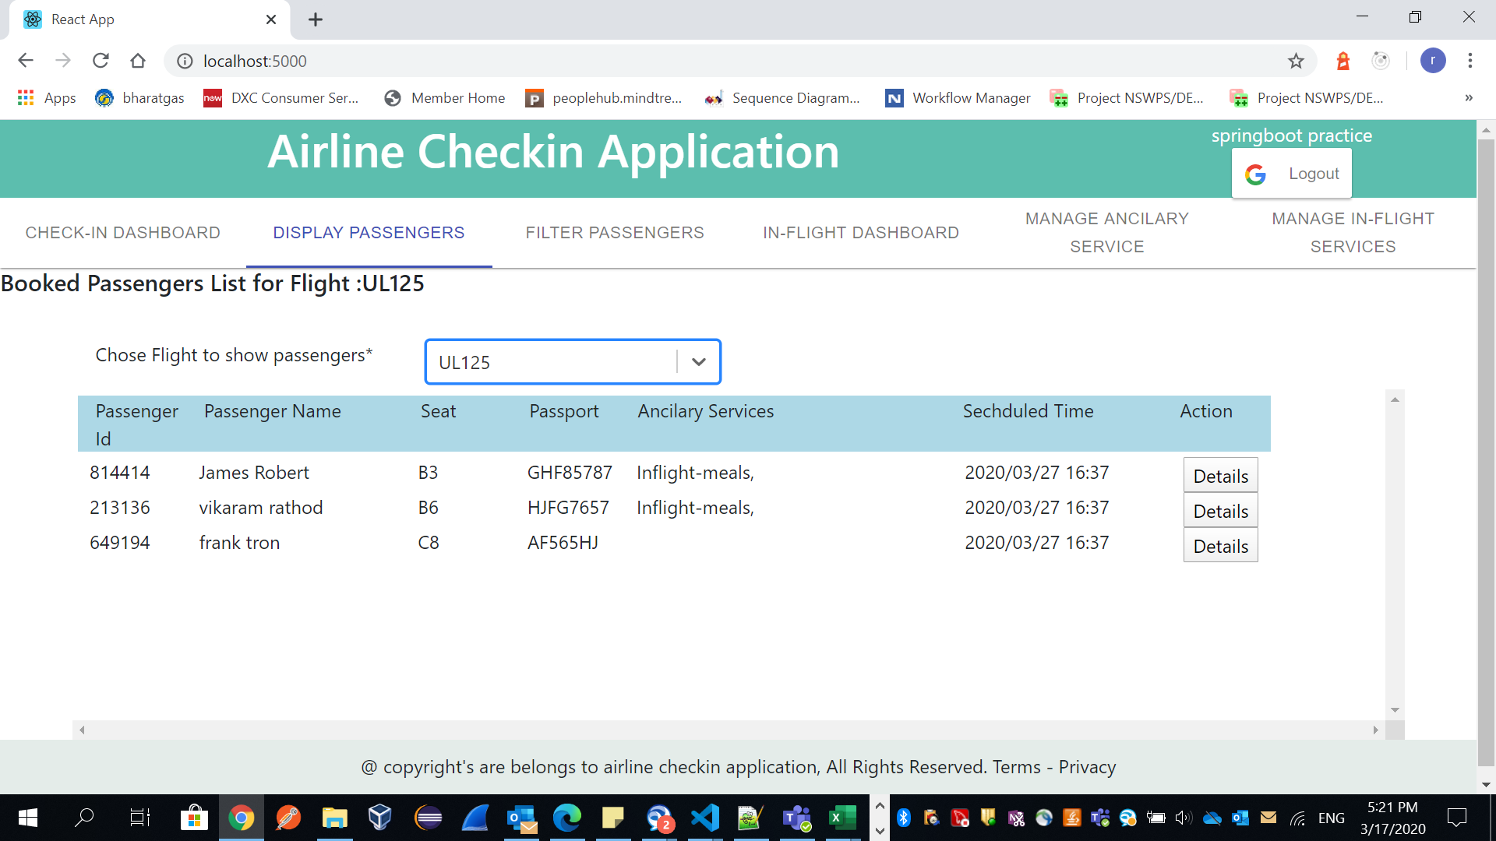

Anther flight:

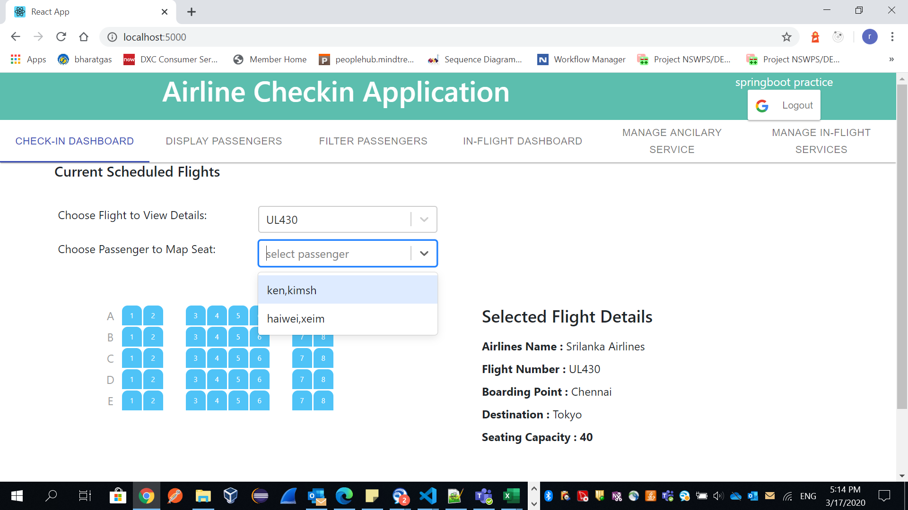

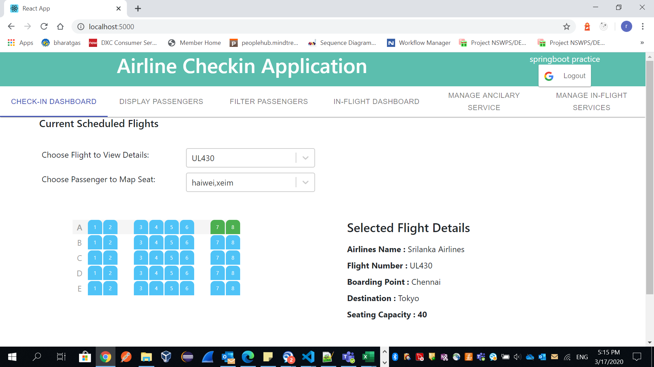

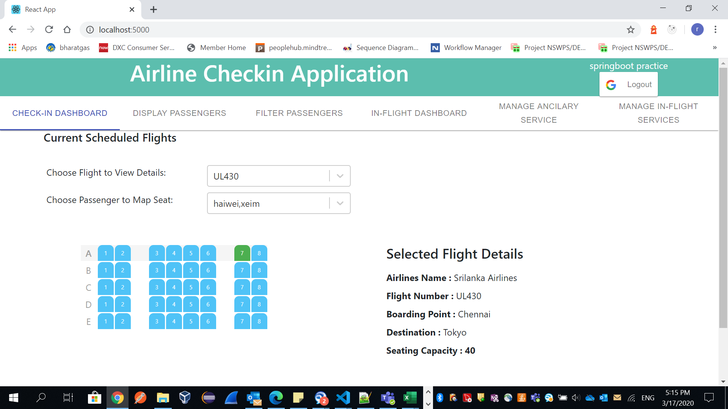

**Filter passengers:**

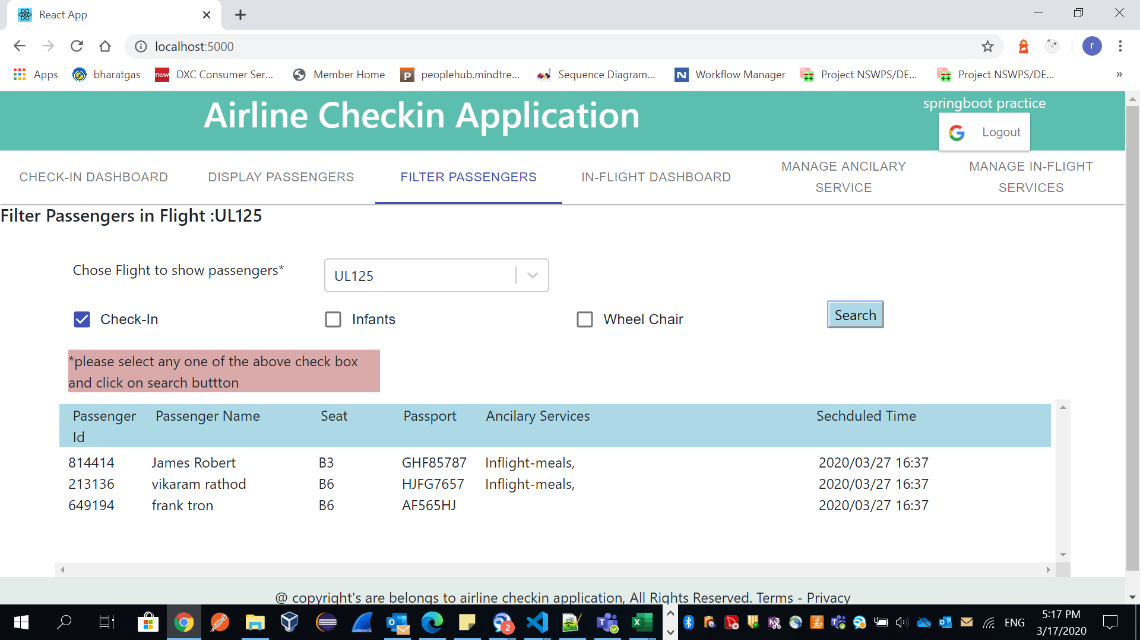

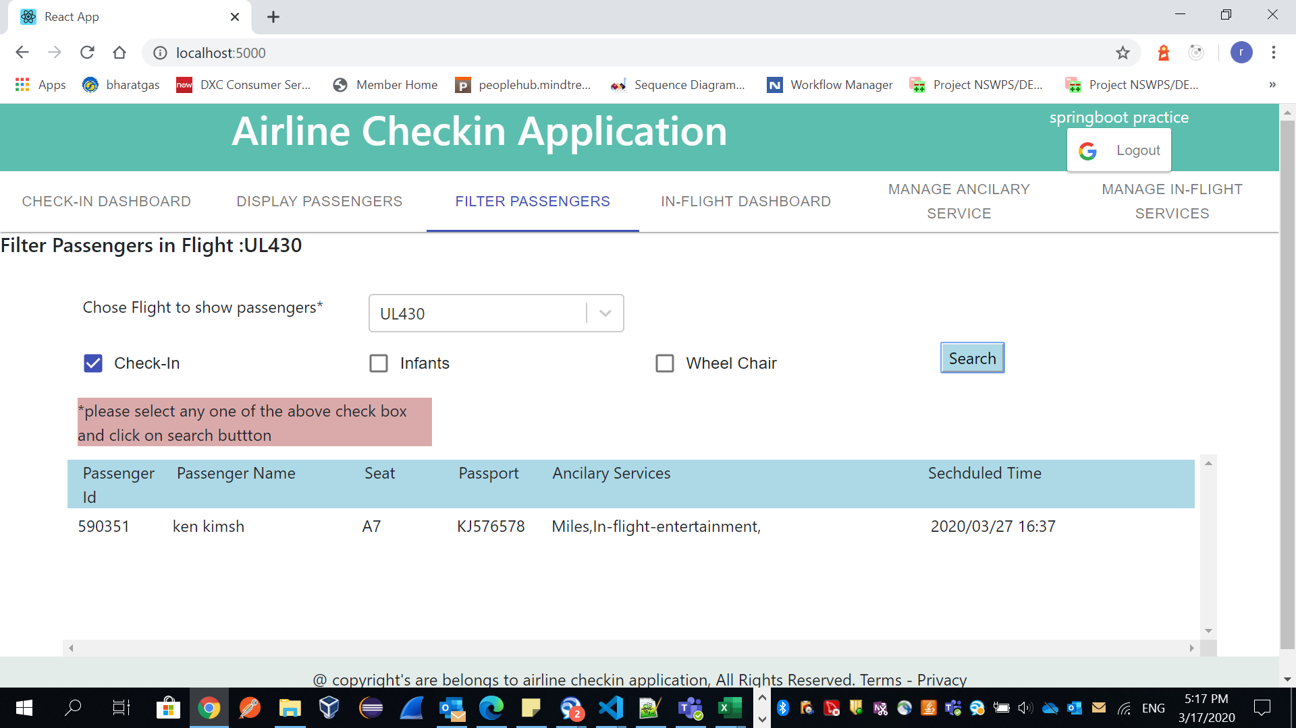

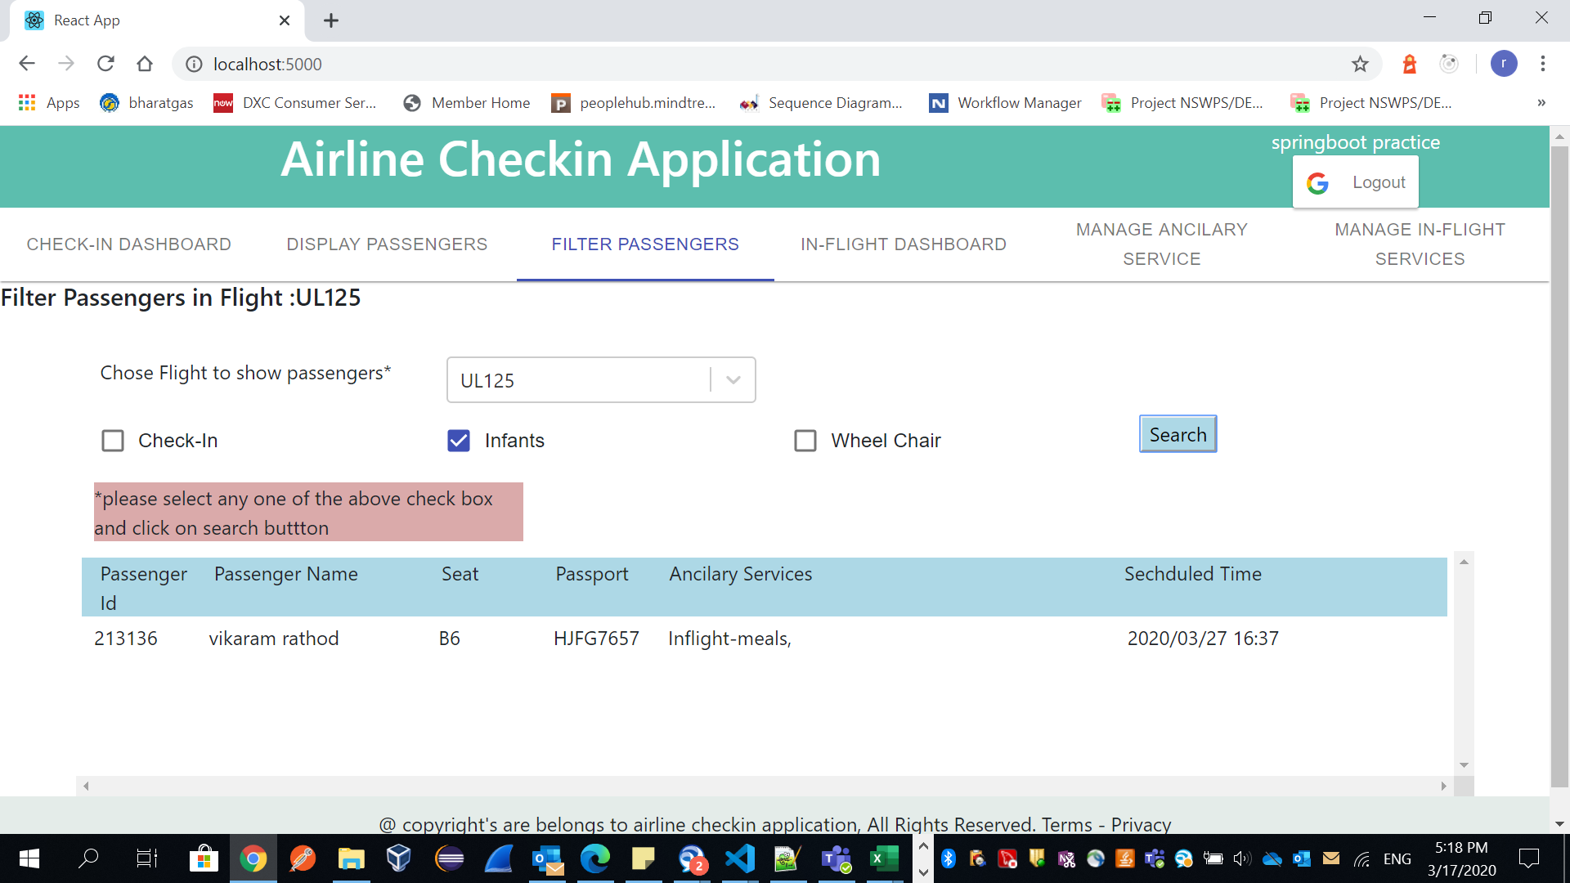

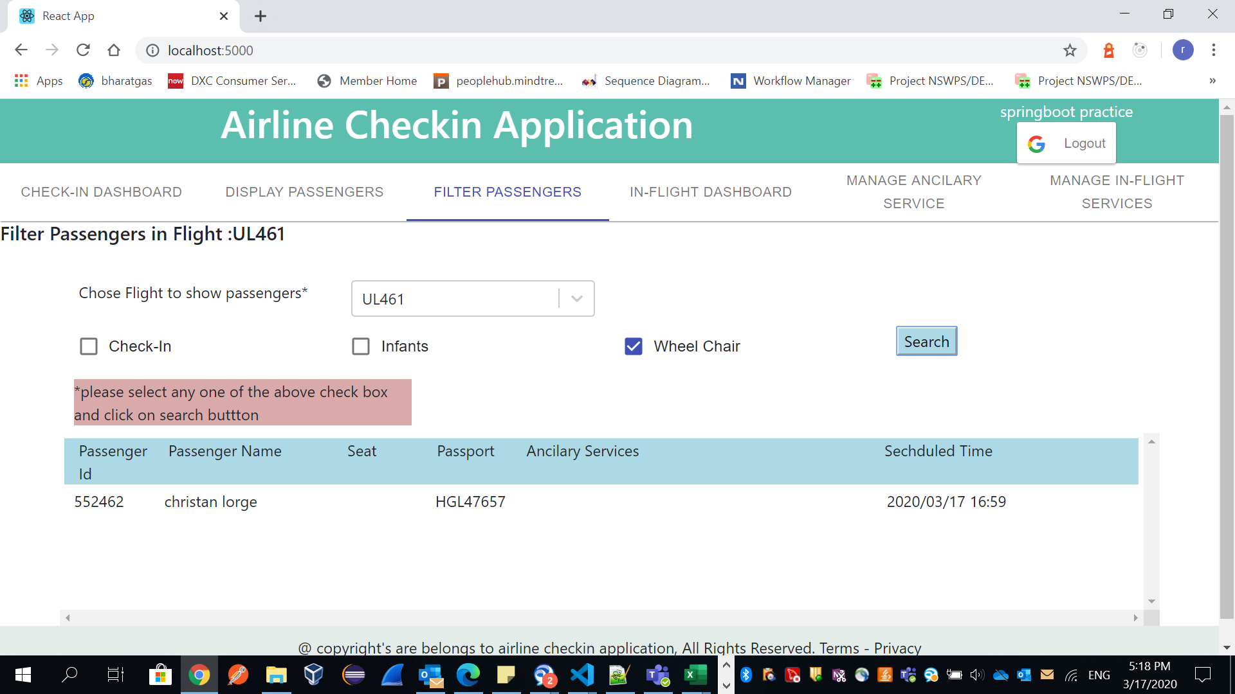

**In Flight Services:**

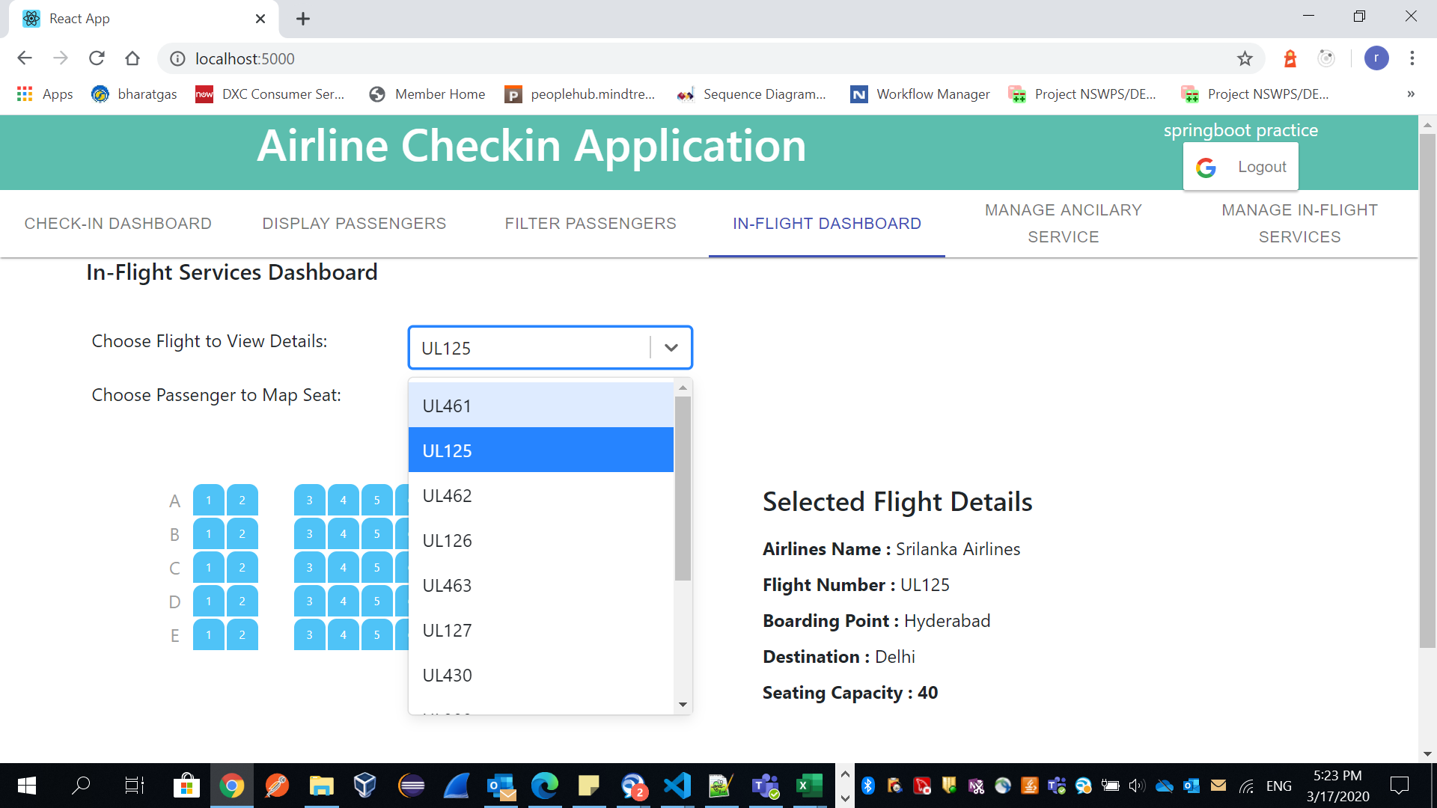

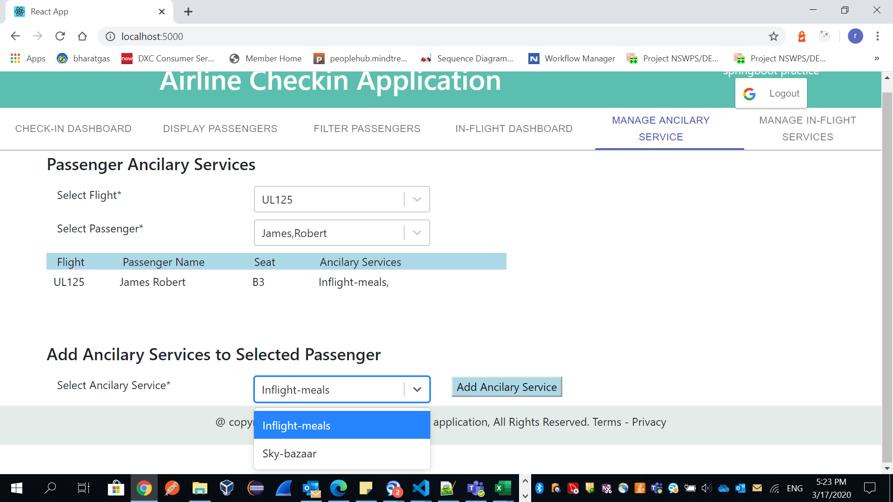

**Here we can add ancillaries to passenger if required.**

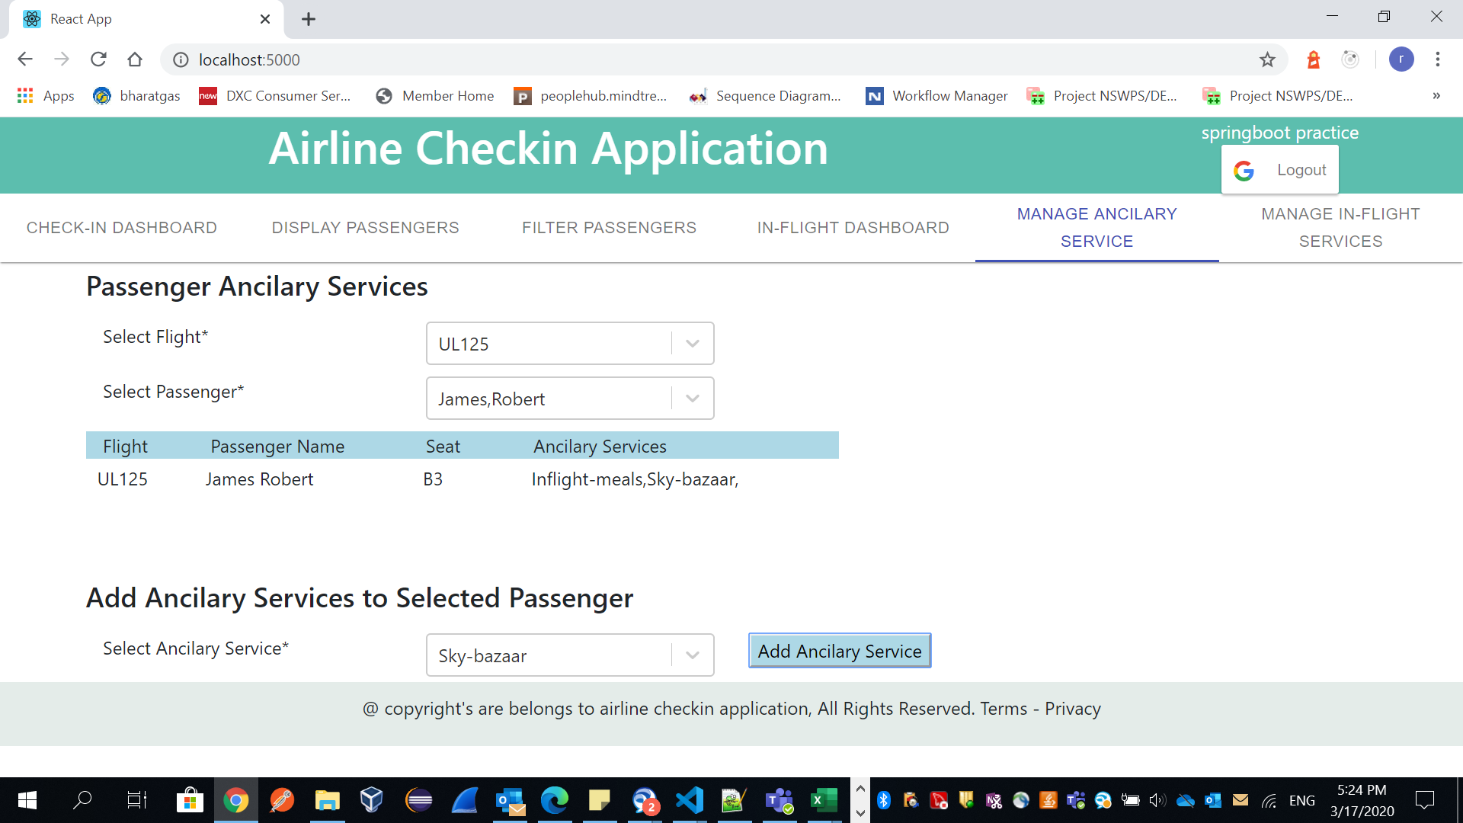

**Meals Preference and Shopping Request:**

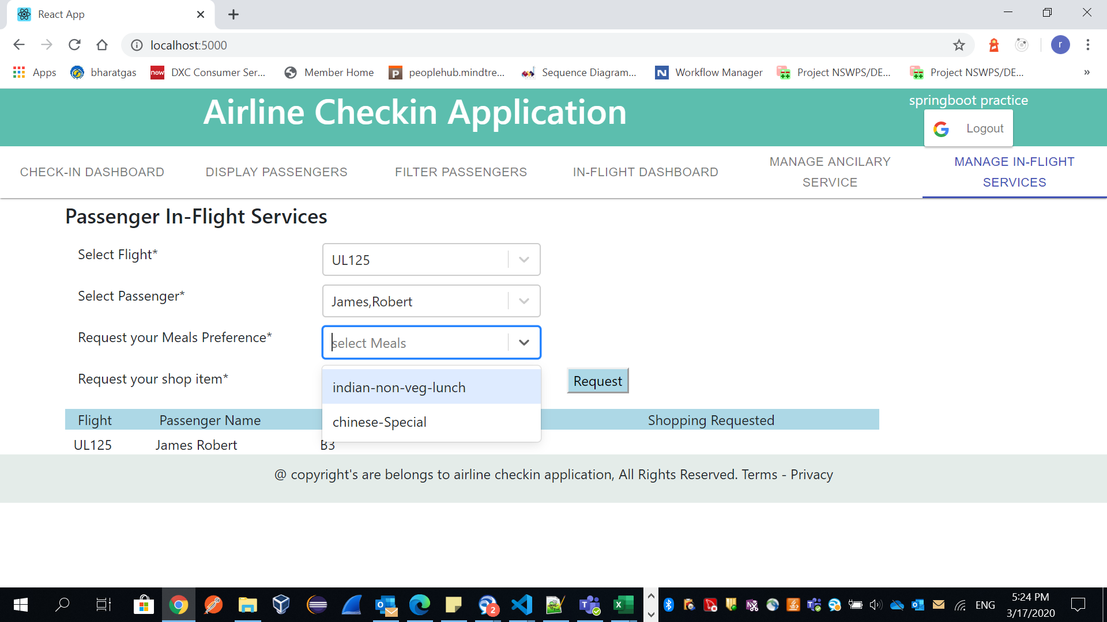

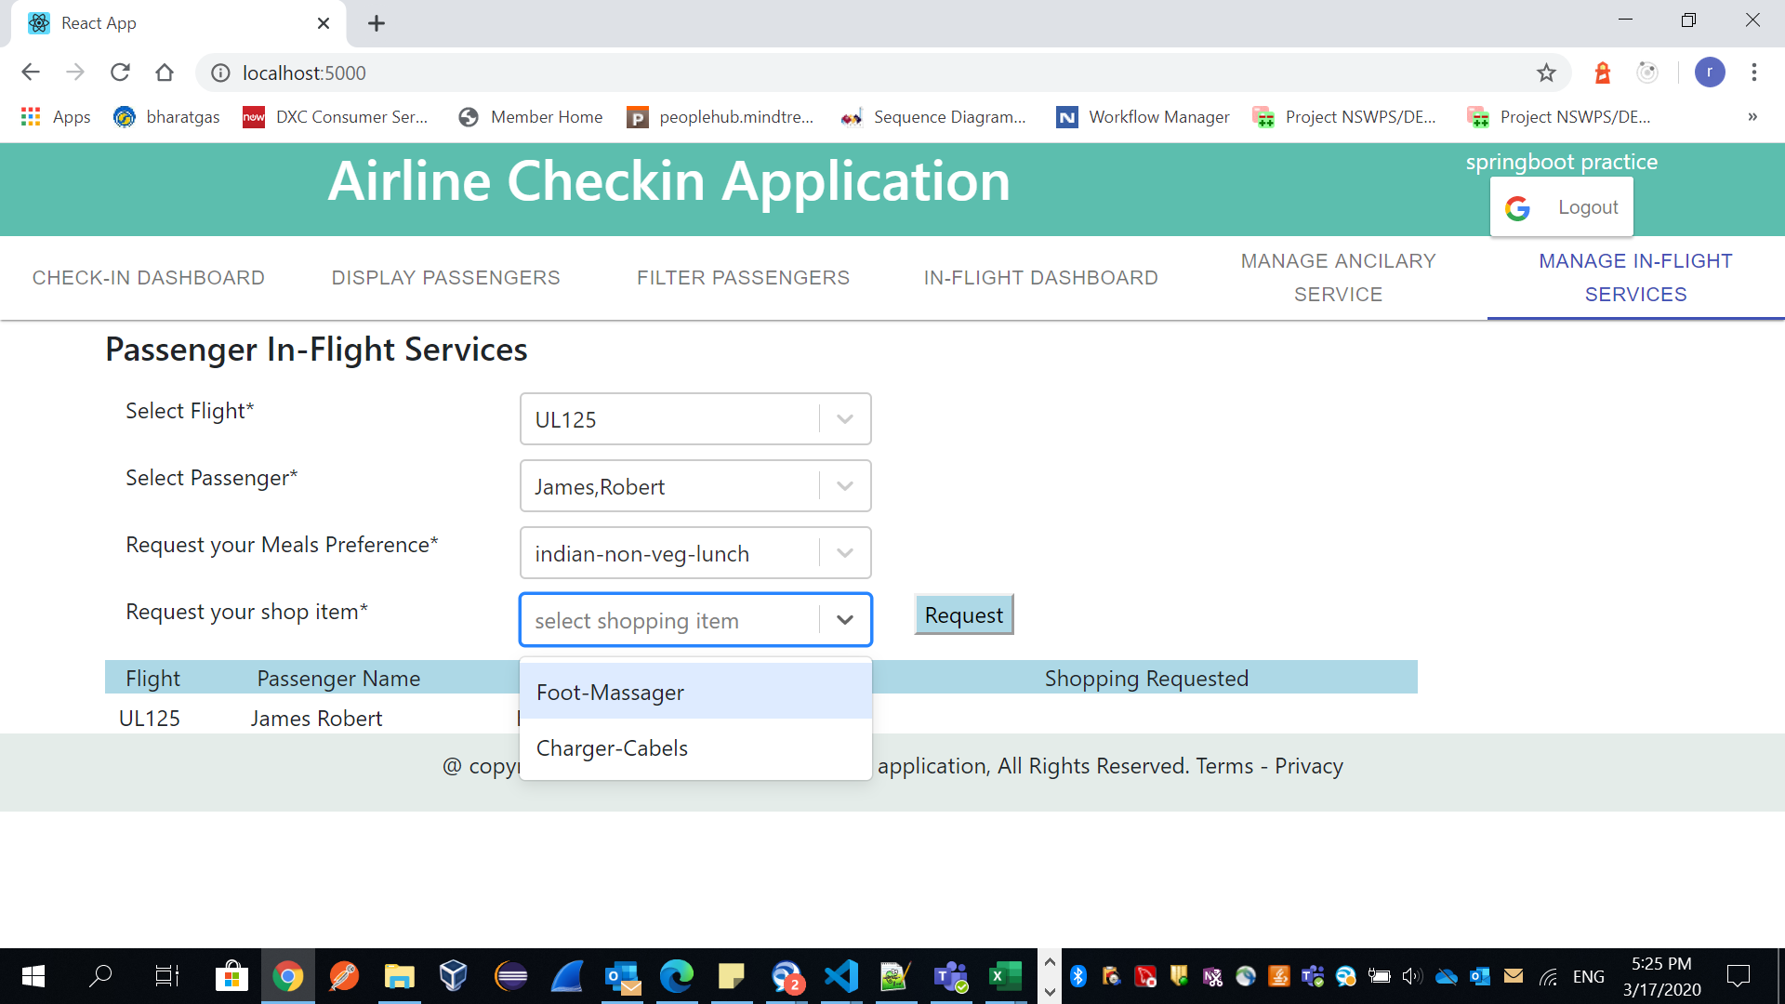

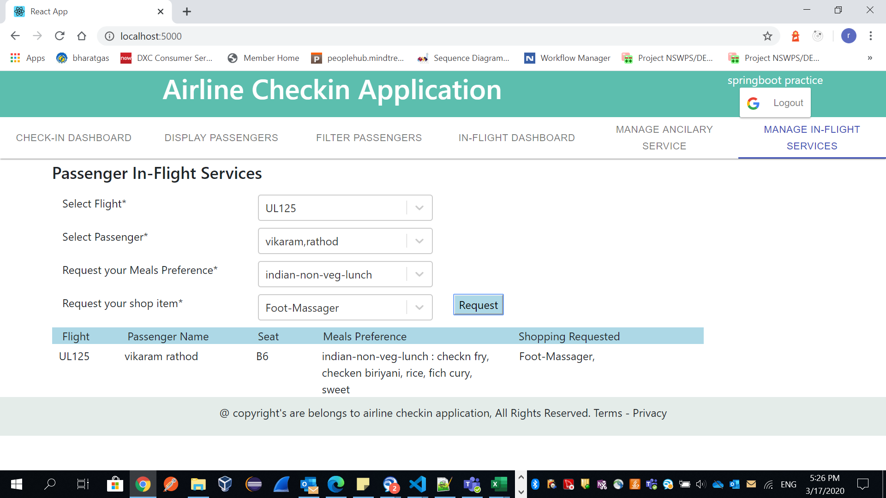

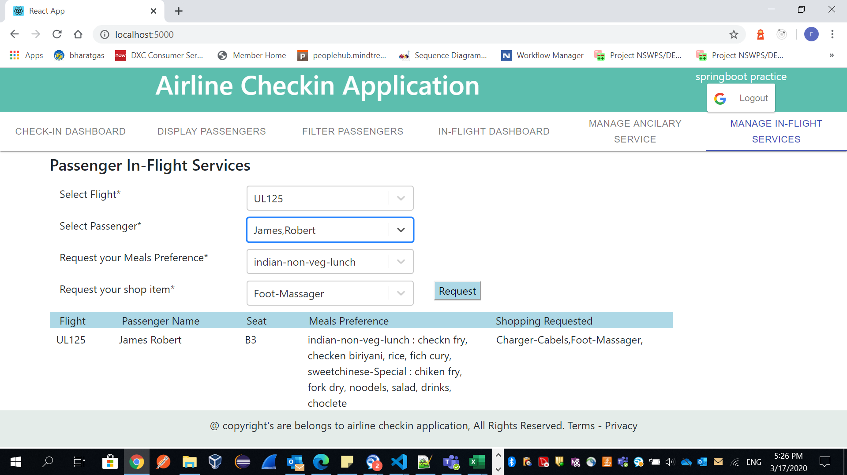

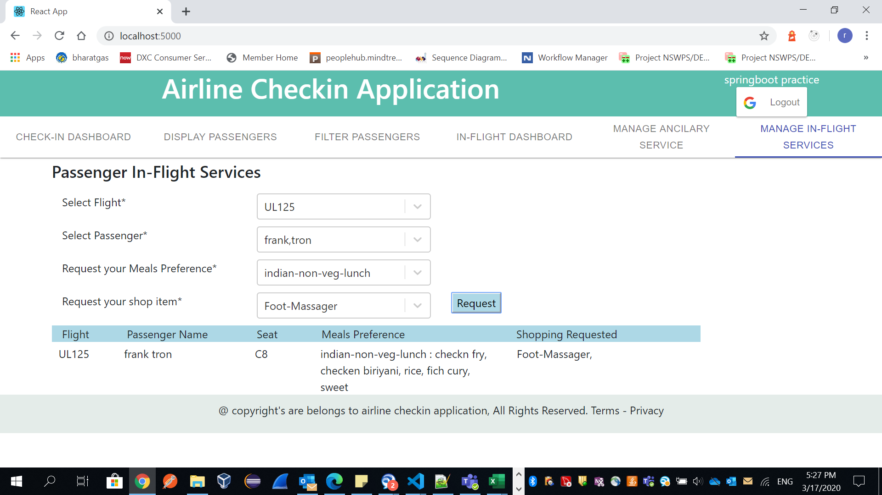

**Add ancillary to passenger:**

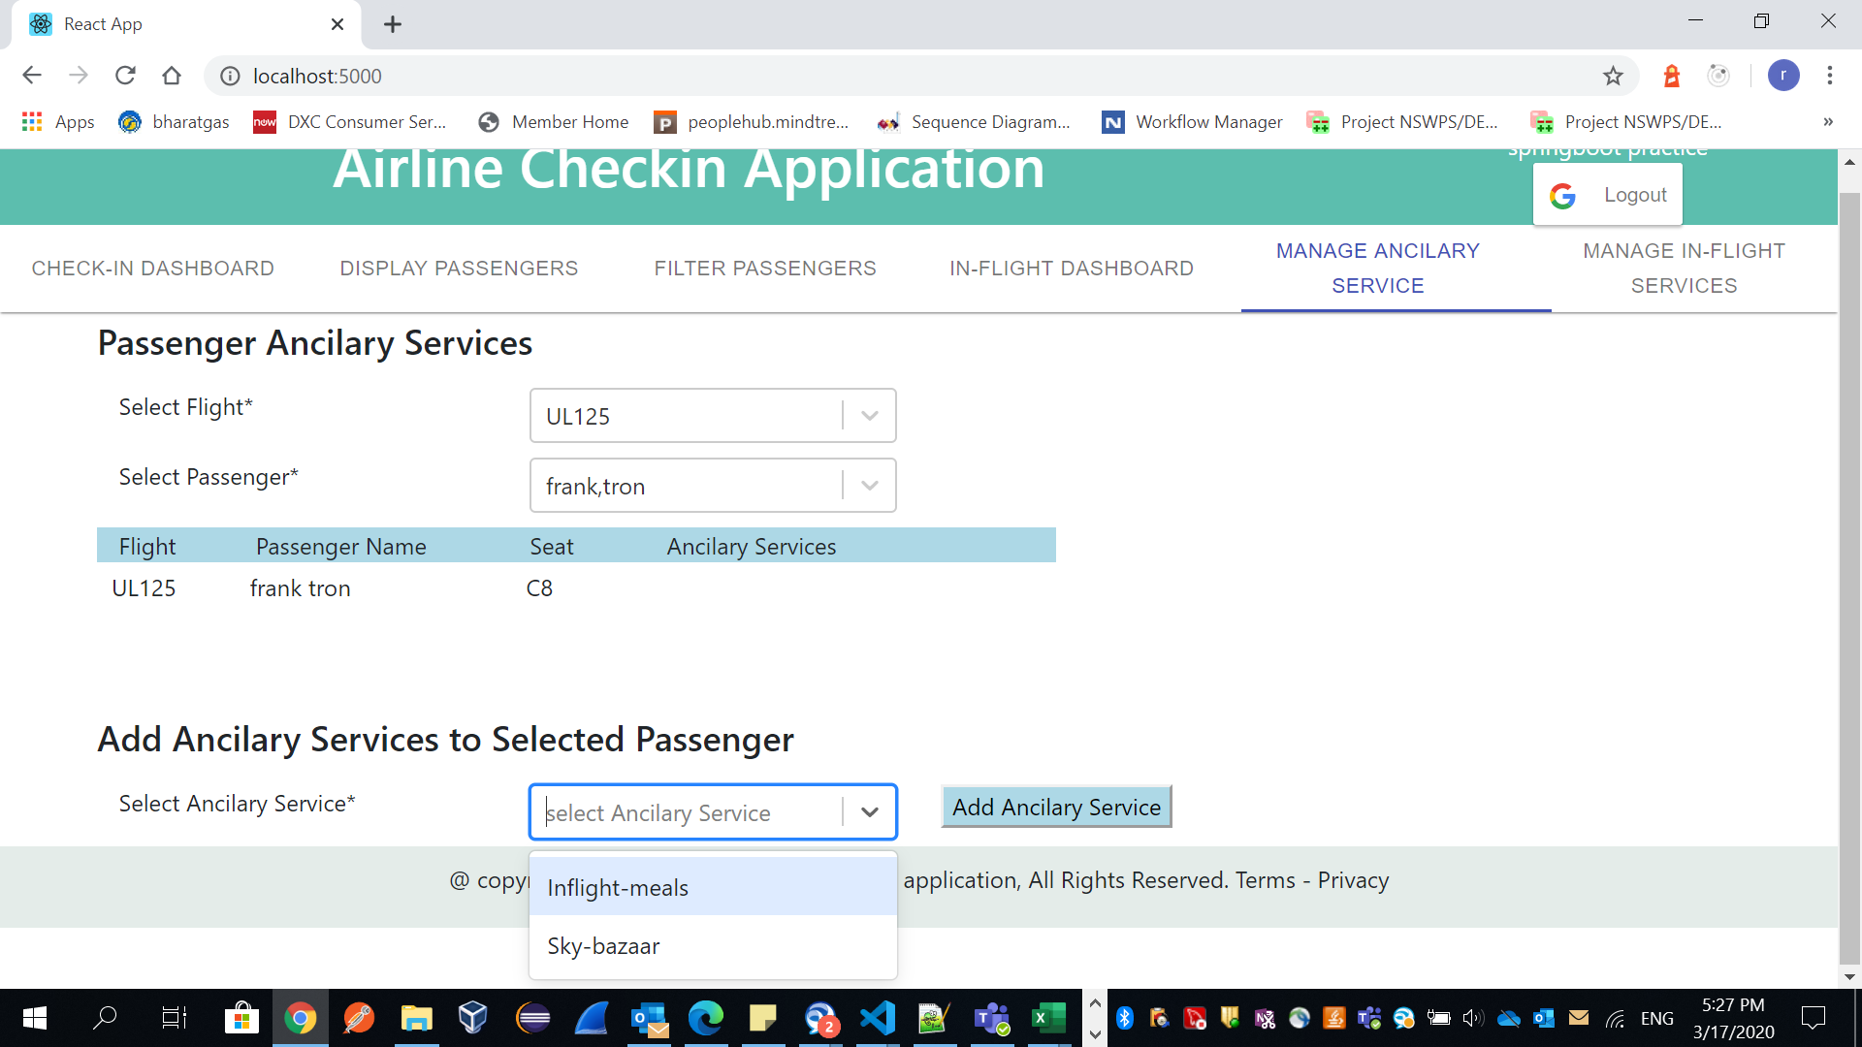

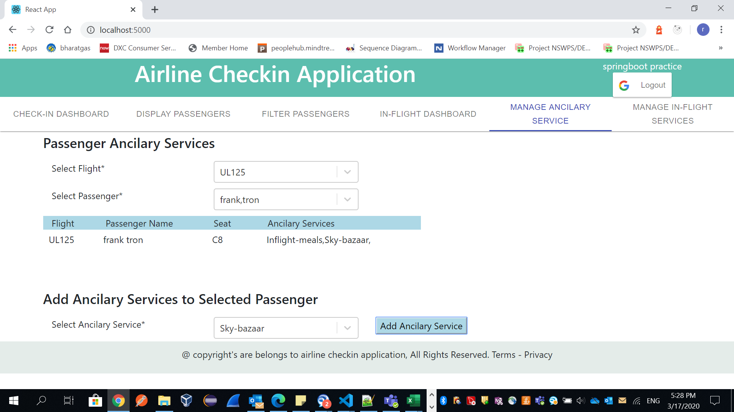

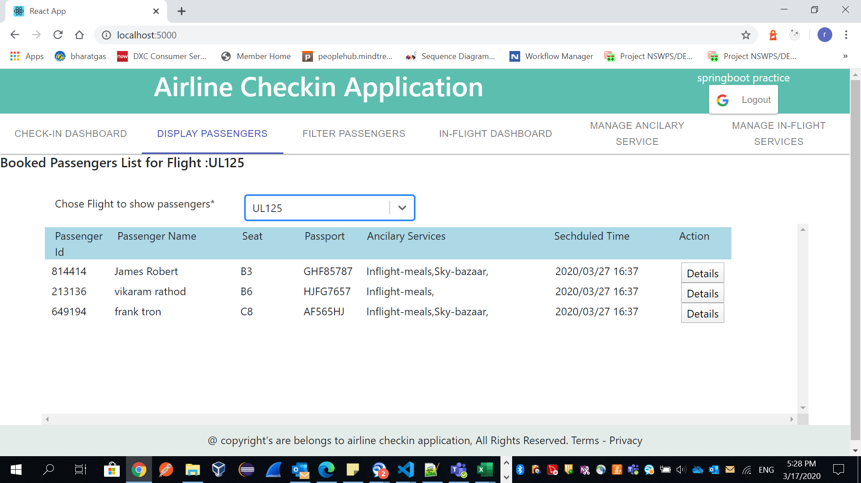

**Note*: Detail button not implemented, assume on click on details button it will show full details of passenger in anther screen.**

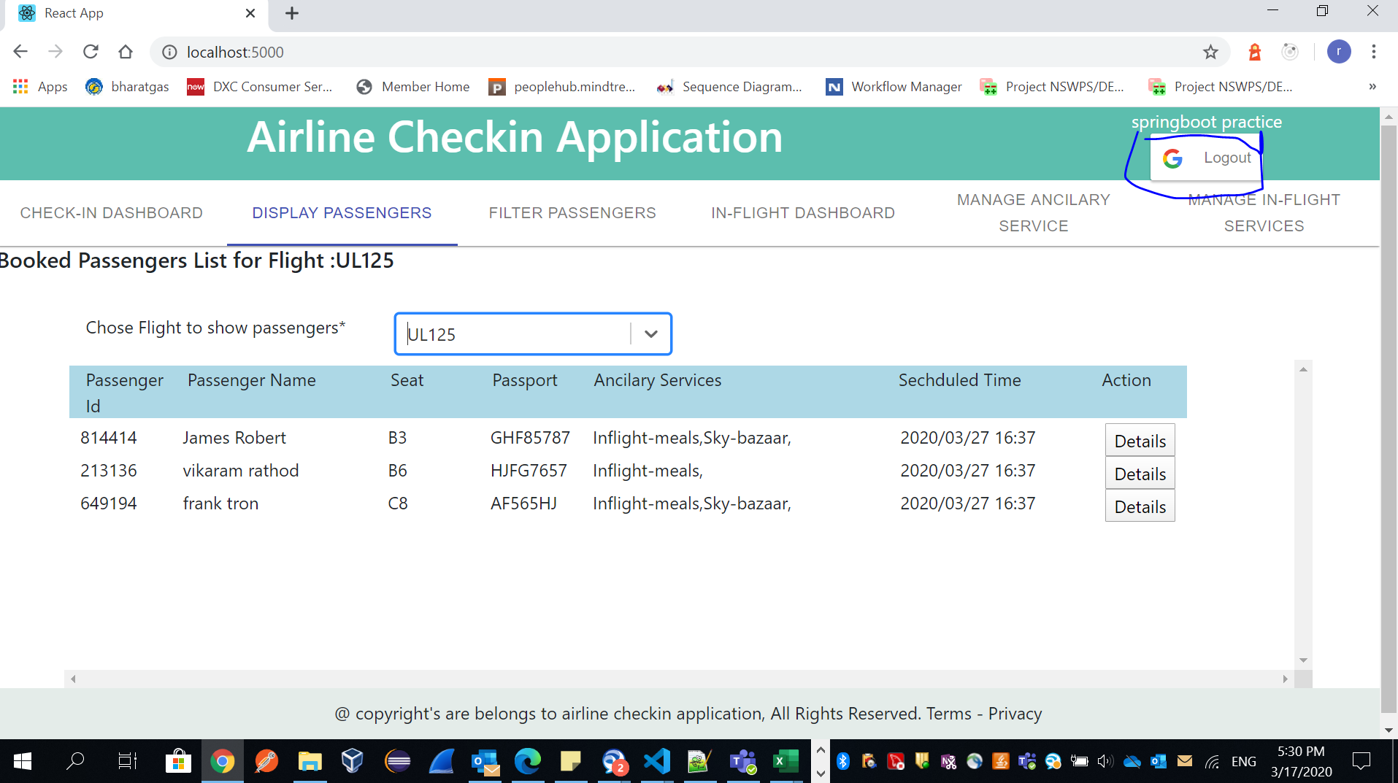

**Click logout button to logoff.**

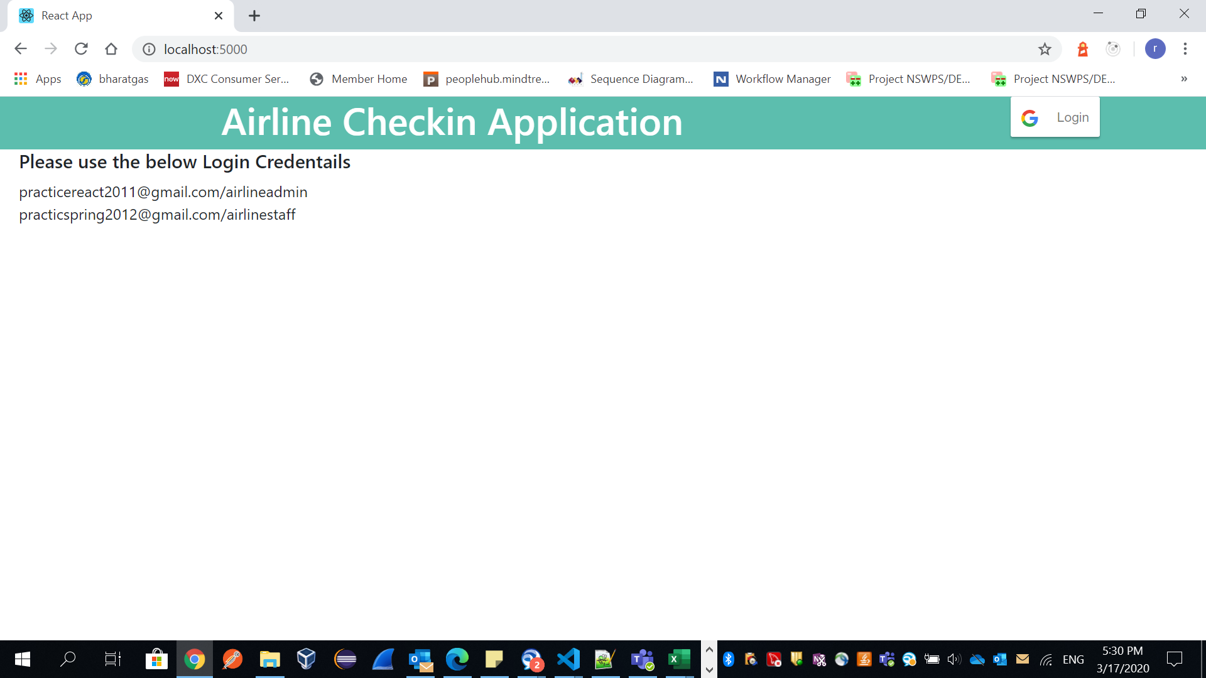

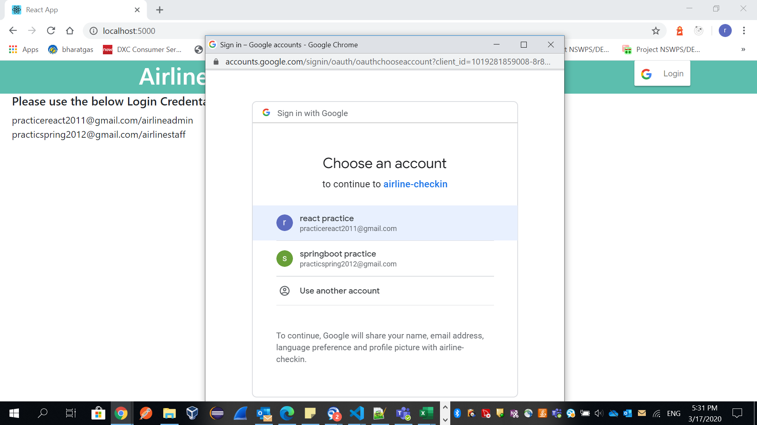

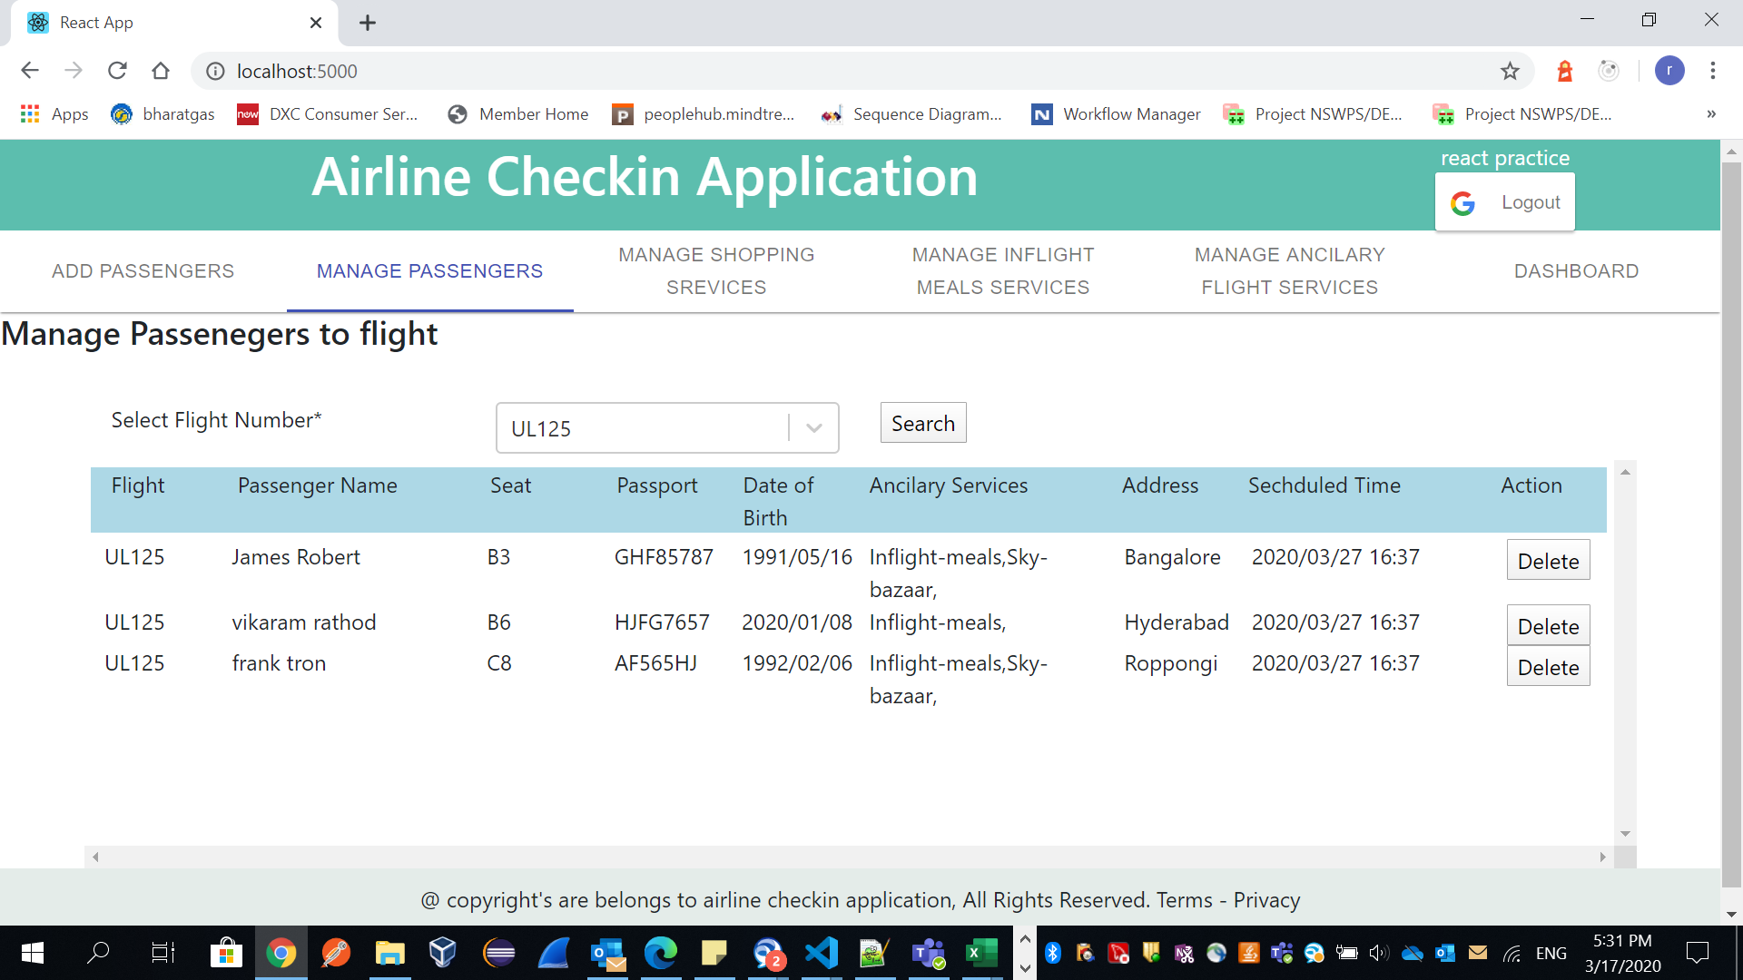

**We can observe here, seat number is updated in Check-in process and information store in Redux and it can visible in admin page as well.**

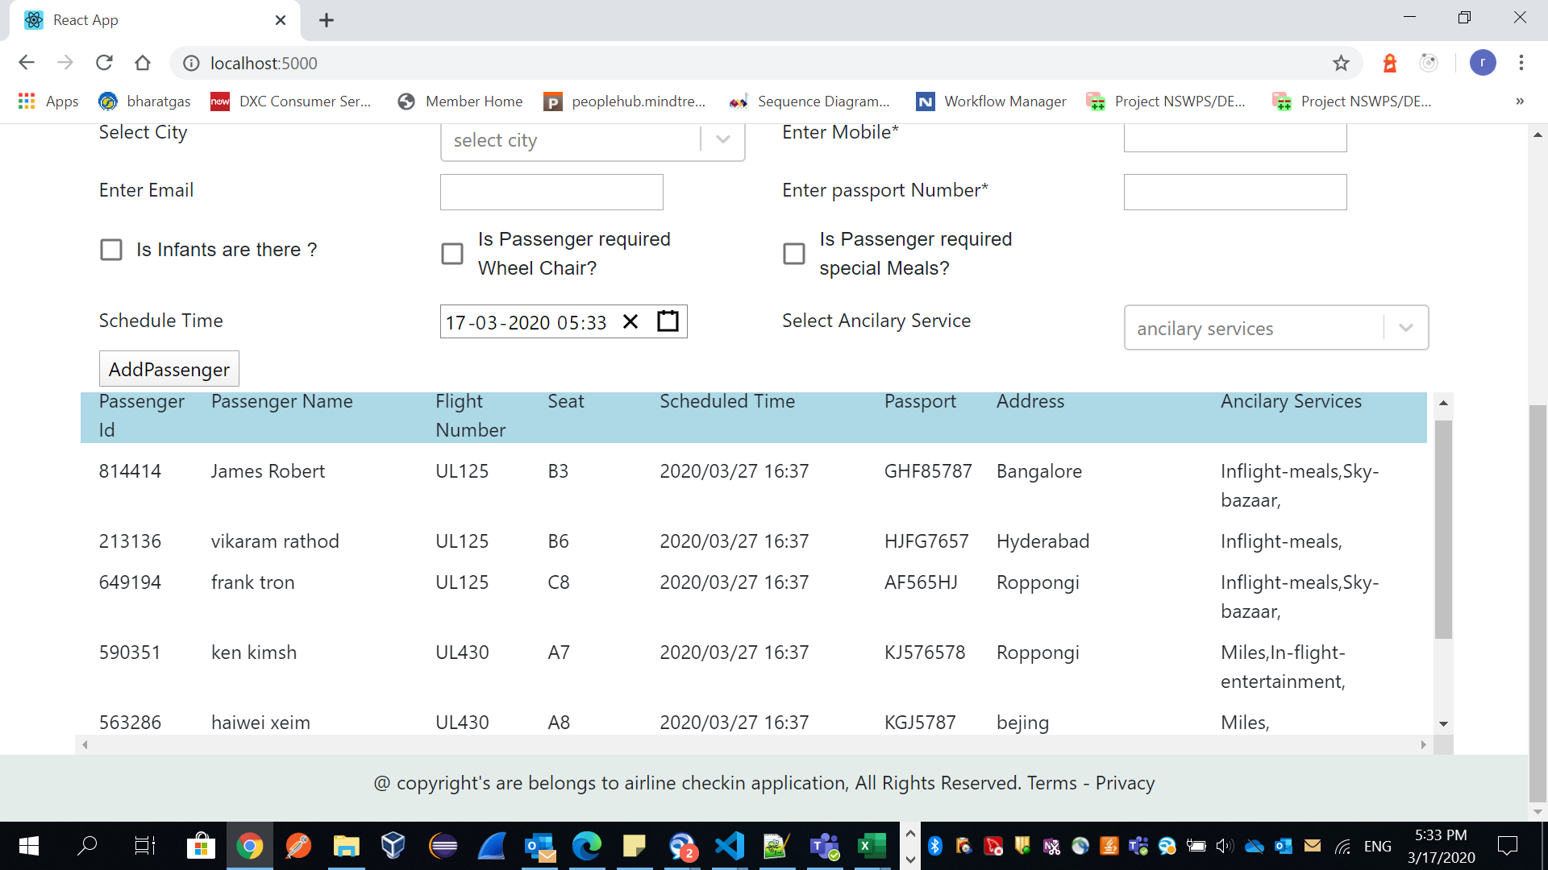

**Some of code snapshots:**

import {createStore, applyMiddleware, compose} from "redux";

import rootReducer from "./reducers";

import reduxImmutableStateInvariant from "redux-immutable-state-invariant";

export default function configureStore(intiateState){

    const composeEnhancers =window.__REDUX_DEVTOOLS_EXTENCION_COMPOSE__ || compose;

    return createStore (

        rootReducer,

        intiateState,

        composeEnhancers(applyMiddleware(reduxImmutableStateInvariant()))

    );

}

import {combineReducers} from "redux";

import passengers from "./passengerReducer";

import flightAncilaryServices from "./ancilaryReducer"

import addAncilaryServices from "./addAncilaryReducer"

import filterPassengerList from "./filterPassengerReducer"

import filterServiceList from "./filterServiceReducer"

import flightFilteredAncilaryList from "./filterAncilaryReducer"

import checkinSearchPassengers from "./checkinPassengersReducer"

import currentScheduledFlightCheckinMap from "./currentScheduleFlightsCheckinReducer"

import filterCheckinPassenger from "./filterCheckinPassengerReducer"

import mealsPreferencePerFlight from "./mealsPreferenceReducer"

import shoppingRequestPerFlight from "./shoppingRequestReducer"

const rootReducer = combineReducers({

    passengers: passengers,

    flightAncilaryServices: flightAncilaryServices,

    addAncilaryServices: addAncilaryServices,

    filterPassengerList: filterPassengerList,

    filterServiceList: filterServiceList,

    flightFilteredAncilaryList: flightFilteredAncilaryList,

    checkinSearchPassengers: checkinSearchPassengers,

    currentScheduledFlightCheckinMap:currentScheduledFlightCheckinMap,

    filterCheckinPassenger: filterCheckinPassenger,

    mealsPreferencePerFlight: mealsPreferencePerFlight,

    shoppingRequestPerFlight: shoppingRequestPerFlight

});

export default rootReducer

import * as types from "../actions/actionTypes";

export default function passengerReducer(state =[], action){

    switch(action.type){

        case types.ADD_PASSENGERS :

            debugger;

            return [...state, {...action.passenger}];

        case types.DELETE_PASSENGERS :

            debugger;

            return [...state.filter(service => service.passengerId !== action.deleteId)];

        case types.UPDATE_SEAT_PASSENGERS :

            debugger;

           /* return [...state, {...action.passengers.map(passenger => (

                passenger.passengerId === action.passengerId ?

                [passenger.seat = action.seat,

                passenger.checkin = action.checkin] : passenger))}];*/

            return [...action.passengers];

        default :

            return state;

    }

}

import * as types from "../actions/actionTypes";

export default function addAncilaryReducer(state =[], action){

    switch(action.type){

        case types.CREATE_ANCILARY :

            debugger;

            return [...state, {...action.addAncilaryService}];

        case types.DELETE_ADDANCILARY :

            debugger;

            return [...state.filter(service => service.serviceId !== action.deleteId)];

        default :

            return state;

    }

}

import * as types from "./actionTypes";

export function createPassenger(passenger){

    debugger;

    return {

        type: types.ADD_PASSENGERS, passenger:passenger

    };

}

export function deletePassenger(passenger, deleteId){

    debugger;

    return {

        type: types.DELETE_PASSENGERS, passenger:passenger, deleteId:deleteId

    };

}

export function searchPassenger(passenger, flightNumber){

    debugger;

    return {

        type: types.SEARCH_PASSENGERS, passenger:passenger, flightNumber:flightNumber

    };

}

export function filterPassenger(passenger, flightNumber, passport, dob, address){

    debugger;

    return {

        type: types.FILTER_PASSENGERS,

        passenger:passenger,

        flightNumber:flightNumber,

        passport:passport,

        dob:dob,

        address:address

    };

}

export function filterAncilaryAction(flightAncilaryService, flightNumber){

    debugger;

    return {

        type: types.FILTER_ANCILARY, flightAncilaryService:flightAncilaryService, flightNumber:flightNumber

    };

}

export function updatePassengerAction(passengers){

    debugger;

    return {

        type: types.UPDATE_SEAT_PASSENGERS,

        passengers:passengers

    };

}

export function filterCheckinPassengerAction(passenger, flightNumber, checkin, infants, wheelChair){

    debugger;

    return {

        type: types.FILTER_CHECKIN_PASSENGERS,

        passenger:passenger,

        flightNumber:flightNumber,

        checkin:checkin,

        infants:infants,

        wheelChair:wheelChair

    };

}

import * as types from "./actionTypes";

export function addAncilaryAction(addAncilaryService){

    debugger;

    return {

        type: types.CREATE_ANCILARY, addAncilaryService:addAncilaryService

    };

}

export function deleteAddAncilaryAction(addAncilaryService, deleteId){

    debugger;

    return {

        type: types.DELETE_ADDANCILARY, addAncilaryService:addAncilaryService, deleteId:deleteId

    };

}

AddPassengers.propsType = {

    passengers: PropTypes.array.isRequired,

    flightAncilaryServices: PropTypes.array.isRequired,

    actions: PropTypes.object.isRequired

};

function mapStateToProps (state) {

    return {

        passengers: state.passengers,

        flightAncilaryServices: state.flightAncilaryServices

    };

}

function mapDispatchtoProps(dispatch) {

    return {

        //createPassenger: passenger => dispatch(passengerAction.createPassenger(passenger))

        actions: bindActionCreators( passengerAction , dispatch)

    }

}

export default connect(mapStateToProps,

    mapDispatchtoProps

    )(AddPassengers);

**Note: Don’t refresh browser, because we will lose Redux store Data.**